Communication & Presentation Skills

- Save this Word Document to your own computer or device. It’s your workbook and no one else will have access to it.
- Work through the different activities at your own pace – there are videos to watch and activities to develop and enhance your communication and presentation skills.
- Remember to take regular breaks.
- When you have finished each part, save your work, take a break and when you are ready, move on to the next section.

We are really keen for you to be involved, so as you work through this module you will see the following icons to let you know what to do.

 | Read |  | Watch
 | Listen |  | Complete

Good luck and enjoy!

Introduction and welcome

Welcome to the Presentation and Communication Skills module. In this module, we will start by looking at what makes an effective communicator and then move on to focus on presentation skills. Remember, these are essential skills for school, college, university, work and everyday life.

Watch, listen and take part to get the best possible experience from this module. We’re with you every step of the way.

Contents
- What makes an effective communicator? – We spend our day communicating with different people about different topics. Possibly without knowing it, we are already experts in what makes an effective communicator. In the initial task, you’ll be thinking about your own experience and identifying the key criteria for making communication work!
- Your communication toolkit – voice, confidence and body language are the key tools for effective communication. We’ll focus on each of these in turn to enable you to develop your own skill set.
- Creating and delivering a presentation – Helen will take you through the essential steps to create and deliver an excellent presentation. Following this, there will be an opportunity for you to make your own presentation, together with some important advice on engaging with your audience.
- The Elevator Pitch – in this section, we’ll use a famous marketing technique as an examination preparation tool.
What makes an effective communicator?

Take a few minutes to think about three people who you think are effective communicators. Your three communicators may be from the media, politics, public figures; they may be friends, relations or teachers. Write their names in the table below:

Three effective communicators
Click or tap here to enter text.
Click or tap here to enter text.
Click or tap here to enter text.

Now, take one of your effective communicators. Think carefully about why you have chosen them. Write their name in the box below and list five factors that make them effective.

My effective communicator: type name here
Factor 1 | Click or tap here to enter text.
Factor 2 | Click or tap here to enter text.
Factor 3 | Click or tap here to enter text.
Factor 4 | Click or tap here to enter text.
Factor 5 | Click or tap here to enter text.

Communication skills valued by educators and employers

If you google ‘communication skills’ on the internet – you will find tens of thousands of websites offering a range of information – descriptions, advice and training courses. There is no doubt that these skills are important. Most surveys of educators and employers offer a list of the top factors that affect your communication skills – below we have put together a top 5.
❶ Listening skills
Being a good listener is one of the best ways to be a good communicator. No one likes communicating with someone who is only interested in putting their own views across and does not take the time to listen. The key is to show you are listening – pay attention and focus on what the other person is saying, remember to ask questions and engage!

❷ Friendliness
Friendly traits like honesty and kindness help generate trust and understanding when talking to someone. A friendly tone and a smile will always enhance your communication skills.
❸ Non-verbal communication
Your body language, eye contact, hand gestures and tone of voice all help you communicate more effectively. Also, pay attention to the other people’s non-verbal signals whilst you are talking. Often these non-verbal cues show how a person is really feeling. For example, if the person is not looking you in the eye, he or she might not feel comfortable.
❹ An open mind
Really good communicators enter conversations and discussions with flexible, open minds. It’s important that you are open to understanding the points of view expressed by others. Listen and think about what other people are saying. Communication is not just about getting your own points across.
❺ Confidence
Whether you are talking to someone or presenting to a group, it’s important to appear confident in what you are communicating. This confidence often comes from simply believing in what you’re saying. Confidence can also come across in body language (especially eye contact) or just by using a friendly tone.

Your communication toolkit

Your voice
A loud voice cannot compete with a clear voice, even if it’s a whisper.
Barry Neil Kaufman

The first step in becoming an effective communicator is to discover your own voice – its potential range, size and quality. Every individual’s voice has a unique range of sound.

Your voice box or larynx
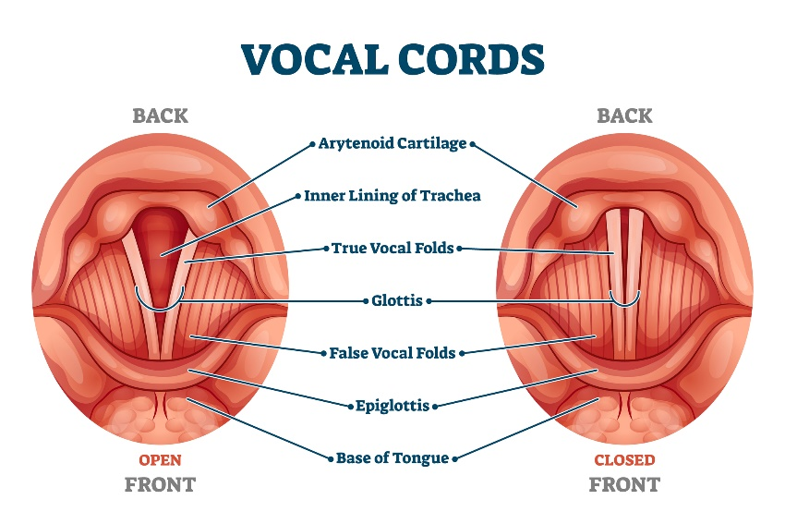
Your voice box is a hollow, tubular structure and it is made of cartilage (connective tissue). It is connected to the top of your windpipe. Inside your voice box are two bands of tissue that form your vocal cords. When you speak or sing, muscles pull these cords together (see diagram above). The air passing through the cords makes them vibrate. We hear these vibrations as sounds. The shorter your vocal cords are and the faster they vibrate, the higher the sound produced.

Your body
Your voice is linked to the whole muscular system of your body. If you feel relaxed, your voice will sound free and open. If you are tense, your voice will be anxious and strained. It’s important to be relaxed in the upper part of your body.

Here are two easy exercises you can do to relax your body and your voice whilst sitting at your computer.
Stretching
- stretch first one arm and then the other
- yawn loudly as you stretch to loosen your jaw and open your throat
- stretch both arms together, yawning loudly.
- raise your shoulders to your ears and allow them to drop with their own weight – repeat four times
- raise your shoulders again, but this time scrunch your face muscles and tense the muscles down your arm holding for a count of five
- release facial muscles and shoulders, letting them fall and relax
- stretch both arms together, yawning loudly.

Your breathing
Breathing is something we all do without thinking about it, but the way we do it can usually be improved and this will have a very real benefit to our voices. Efficient breathing is one of the essential requirements for good voice production. Your breathing should always be relaxed and rhythmic. Look carefully at the diagram below:
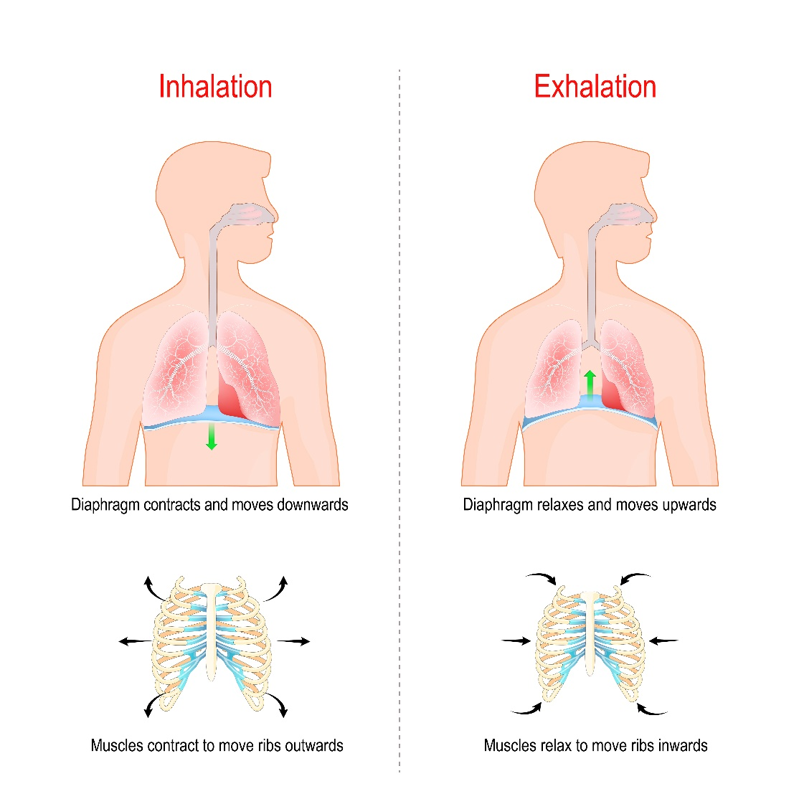
As your lower rib cage expands, the diaphragm is lowered and the space inside the ribcage increases, allowing the lungs to expand. There should be minimum movement in the shoulders and upper chest, so that the airflow that supports the voice is not blocked.

Confidence
Confidence is key to being a good communicator. Think back to the three effective speakers you chose at the beginning of this module – it’s highly likely that confidence was a factor in each of your choices. However, it’s important to recognise that you don’t have to be confident – you just need to appear confident!

Confidence can be evident in your facial expression – be enthusiastic, friendly and open. Make sure your voice is clear and lively. Give the impression of being confident, prepared and organised.
Confidence is also linked to the next tool in your toolkit … body language.

Body language
Effective communicators need to be conscious of the power of their own body language. Research suggests that 93% of the impact of a first impression is formed on non-verbal communication. You therefore need to think carefully about your eye contact, posture, facial expressions and gestures.
Let’s test the impact of body language. On the next two pages, you will find a series of images. For each image, identify the body language and what it is conveying. Write in as much detail as possible. There are no right or wrong answers, but it would be interesting to do this with a partner and compare your responses.

Write your ideas here …
Write your ideas here …
Write your ideas here …
Write your ideas here …

Write your ideas here …

Write your ideas here …

Write your ideas here …

Write your ideas here …

Next time you speak to one person or a group of people, think about what impression you are giving through your body language.

Look at the lists of positive and negative body language below. How often do you use these non-verbal cues?
Positive body language  Direct eye contact (not staring)  Warm, open smile  Nodding  Head tilted  Open, inclusive gestures (palms showing)  Fully facing others  Leaning forward  Upright but relaxed posture  Feet firmly planted on ground  Chin up  Sitting forward  Eyebrow flash upon greeting | Negative body language  No eye contact  Tight or no smile  Head down or dropped glances  Not fully facing, at an angle  Leaning away  Hunched shoulders  Stiff posture  Chin into chest  Arms and/or legs crossed  Body sagging  Legs outstretched when seated  Staring  Fidgeting

Creating and delivering a presentation
It is likely that you will have to create and deliver presentations in your programmes of study. In this video, Helen takes us through the essential steps to making and delivering a first-class presentation.
Watch Delivering an excellent presentation here by opening the hyperlink. Remember to put the video on full screen

Helen mentioned the three Ps. Write them in the box below (if you can’t remember them, just rewatch the first minute of the video).

P
P
P

An excellent presentation step-by-step
For this activity, it would be useful to have a presentation in mind that you will need to deliver. This may be for your English GCSE or Functional Skills examination, or it may be a presentation you have to give in class.
Preparation
Step 1: overview
Take an overview. Think about the following questions:
- what is the task?
- what is the purpose of the presentation?
- is it being assessed and if so, what is the assessment criteria?
- who is your audience?

Here is the assessment criteria for GCSE English Language (AQA):
- Demonstrate presentation skills in a formal setting
- Listen and respond appropriately to spoken language, including to questions and feedback on presentations
- Use spoken Standard English effectively in speeches and presentations.
To be awarded a Pass, Merit or Distinction a learner must:
• be audible
• use Spoken Standard English which, for the purposes of the spoken language assessment, means that a learner must – be intelligible and generally use language appropriate to the formal setting of the presentation.

On the next page, you will find the criteria for the different levels.
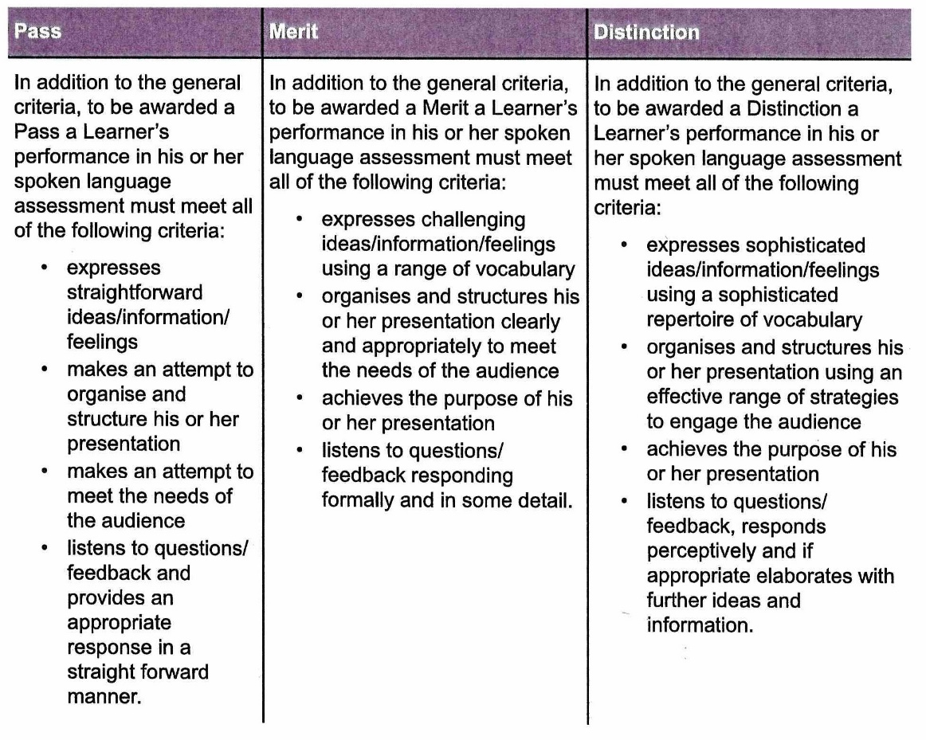
The assessment criteria for Edexcel, OCR and WJEC Eduqas will be similar – details can be found on the exam board website or ask your teacher for more details.

If you are preparing a presentation for Functional Skills, the assessment criteria can again be found on the appropriate website or ask your tutor/coach.

Step 2: generate ideas
For this, you will need a blank sheet of paper. Answer the following questions:
- what is interesting about the topic?
- what does your audience already know about the topic?
- what will your audience be interested in finding out?
- how can you present this topic in the most interesting way?

Step 3: research
Now gather all the information you need about your topic. Think carefully about the best places to research and the best people to talk to. You may want to go back to the Research Skills module and review some of the information there.

Step 4: Detailed plan and script
Making a plan will help you decide what the structure of the presentation will be. You will need to take into account how much time you have and what your key points will be. Think really carefully about your opening and ending. In your opening it is important to engage your audience – how will you do this? In your conclusion, you will need to summarise key learning points and leave your audience with something to think about.

As Helen said, it may be useful to produce a detailed script at this point. Remember to pass the script to your teacher or assessor once you have completed the presentation as it will be a helpful document. On the next page is the start of the Lady Macbeth presentation, Helen talked about. Note how every other line is left blank to allow room for performance notes.

Step 5: visual aids
This step is about thinking about your presentation from the point of view of your audience – are there visual aids which will help them understand key points or keep them engaged during your presentation? So, in the Lady Macbeth example, it may be useful to have the quotation ‘dearest partner of greatness’ on a slide to emphasise its importance.
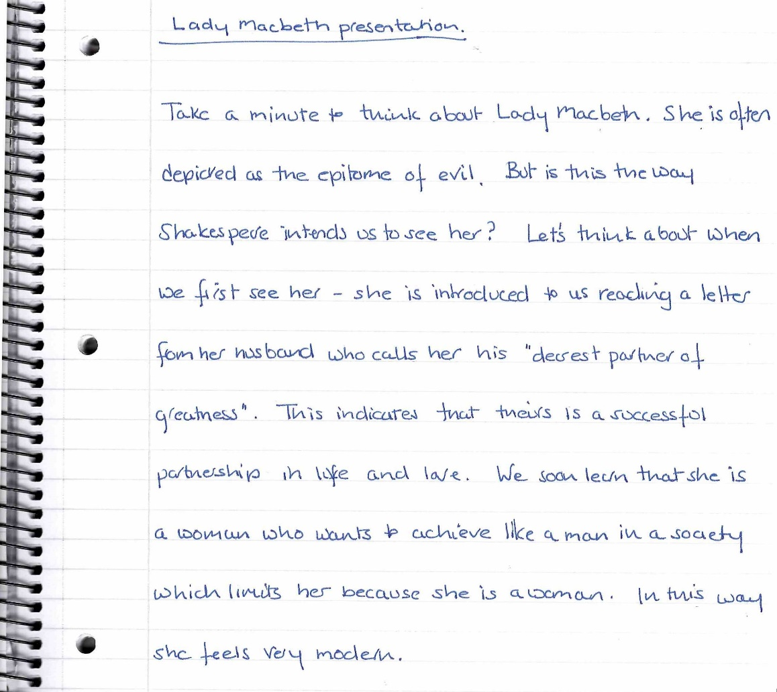
Practise
The more time invested in preparation the better your presentation will be. Read it aloud for the first time and add notes to your detailed script – think about pace, emphasis, tone, pauses.

On the next page, notes have been added to the Lady Macbeth script giving performance hints.

Under the script, you will see a cue card for this section of the presentation.

Remember to practise your presentation as many times as possible.

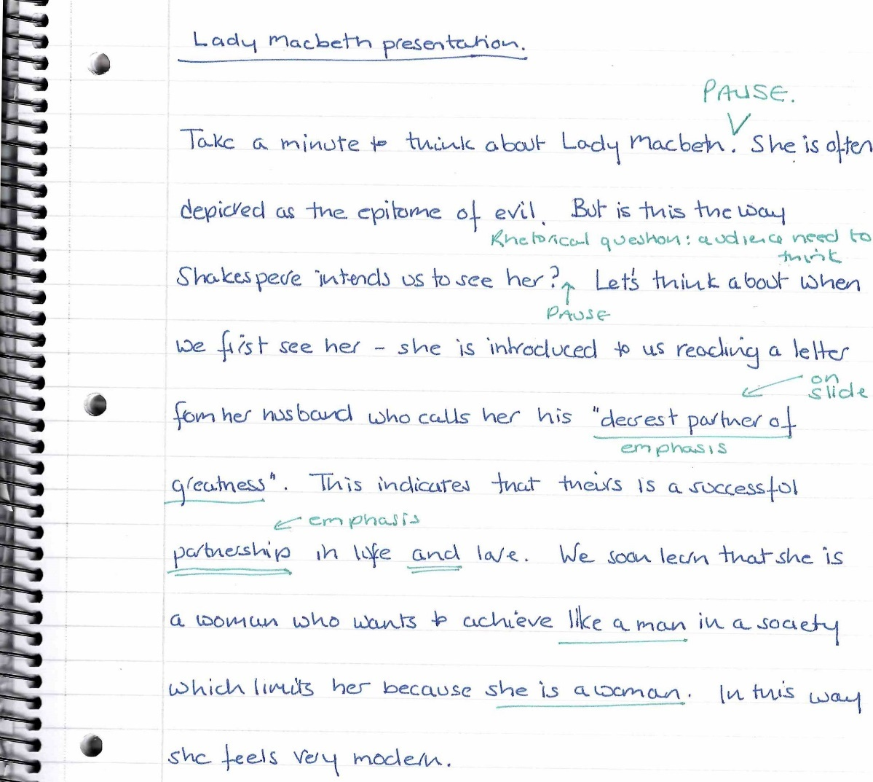

Cue card number
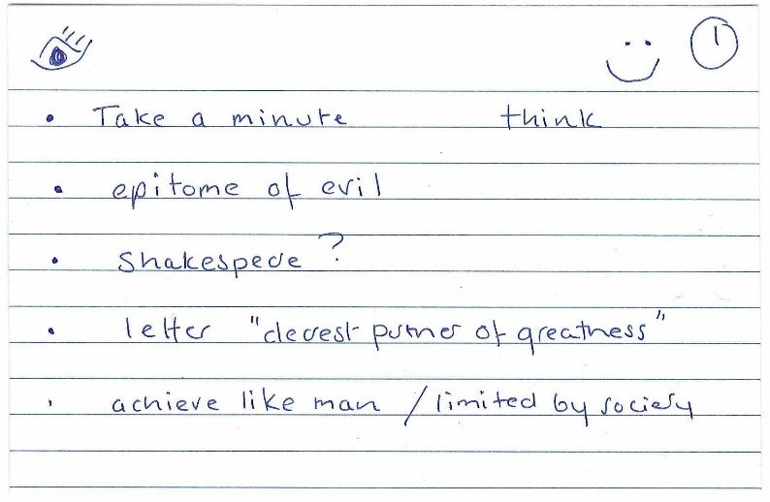
Make eye contact
Smiley face – remember to be friendly and open

Notes of key points

Perform
As Helen said, remember your presentation is a performance. Here are some key points for your opening:
face your audience at all times
stand up straight and stand still at the beginning
talk slightly louder than usual
remember to smile from time to time and maintain eye contact
explain what your talk is about – get their interest!

And, a final but very important point, your audience doesn’t know how you feel inside. They just see what what’s on the outside!

Don’t forget to ask for:

The Elevator Pitch
In this video, Helen will show you how to use mini-presentations for reviewing and revising in preparation for examinations.
Watch The Elevator Pitch - YouTube here by opening the hyperlink. Remember to put the video on full screen
Can you remember the key points about an elevator pitch? Answer the questions below. If you can’t remember, watch the video again
How long should your pitch last? | Click or tap here to enter text.
What is the maximum number of sentences you should use? | Click or tap here to enter text.
What do we call the opening line? | Click or tap here to enter text.
What word will you use to start your explanation? | Click or tap here to enter text.
Can you name one more thing you should include? | Click or tap here to enter text.

Here is a copy of Helen’s elevator pitch:
GRAB LINE  INTRO OF EXPLANATION  MENTAL IMAGE  BRIEF SUMMARY | - We know the key vocabulary for the topic of cells, but to really succeed in the exam, we need to go beyond this.  - Well, let me start by telling you the difference between a cell membrane and a cell wall.  - All cells have a cell membrane – this membrane separates the contents inside the cell from anything outside the cell.  - Think about any cell diagram, the cell membrane will be the inner line.  - If the cell diagram has an outer line, this is the cell wall (and it must therefore be a plant, bacterial or fungal cell).  - To summarise, the membrane is the inner line; the cell wall is the outer line.

Here are some other topics, from a variety of subjects, which you could use for your elevator pitch – but once you start thinking you will have lots of ideas:
any theme from a novel or a play
any character from a novel or a play
respiration and photosynthesis
energy transfers in ecosystems
how tree diagrams work
similar shapes
the difference between mass and weight
the difference between dark matter and dark energy
Elizabeth I’s own religious beliefs

The Dawes Plan

the muscular system

spectator behaviour

constructive and destructive waves

causes of urban growth.

Now make a quick list of your own – fill out the 5 boxes below:
1. | Click or tap here to enter text.
2. | Click or tap here to enter text.
3. | Click or tap here to enter text.
4. | Click or tap here to enter text.
5. | Click or tap here to enter text.
Pick a topic and write your first elevator pitch in the space below:

GRAB LINE | Sentence 1 | Click or tap here to enter text.
WELL… | Sentence 2 | Click or tap here to enter text.
MENTAL IMAGE | Sentence 3 | Click or tap here to enter text.
 | Sentence 4 | Click or tap here to enter text.
 | Sentence 5 | Click or tap here to enter text.
SUMMARY | Sentence 6 | Click or tap here to enter text.

Ask a friend studying the same subject to create an elevator pitch for another curriculum topic.
Share your pitches – easy and fun exam preparation!

We hope you have enjoyed this Presentation and Communication Skills module and that you have found the activities useful. Have a look at the final module Looking after Yourself next.

