Looking After Yourself

- Save this Word Document to your own computer or device. It’s your workbook and no one else will have access to it.
- Work through the different activities at your own pace – there are videos to watch and activities to help you look after yourself during your exams and the exam preparation period.
- Remember to take regular breaks.
- When you have finished each part, save your work, take a break and when you are ready, move on to the next section.

We are really keen for you to be involved, so as you work through this module you will see the following icons to let you know what to do.

 | Read |  | Watch
 | Listen | 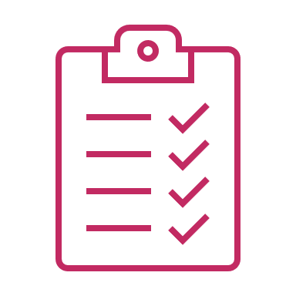 | Complete

Good luck and enjoy!

Introduction and welcome

Welcome to the Looking After Yourself module.

In this module, we will identify ways which will help you cope with the pressures of the exam period.

Watch, listen and take part to get the best possible experience from this module. We’re with you every step of the way.

Contents
- Managing exam pressure – explore how you feel about exams and then watch the video introducing the topic with Dr Felicity Wallace. Use the activities that follow to make sure you are exam-ready!
- Your To Do List – a summary of things you can put in place now to ensure that the exam season is as stress-free as possible.
- Useful websites 1 – some links to websites focusing on keeping healthy throughout the exam period.
- Useful websites 2 - website links to help you manage exam pressure.

Glossary
This glossary provides details of the key words used in this module.
affirmation | A short positive statement about yourself which is intended to encourage or motivate you.
mindfulness | Being mindful is the practice of paying more attention to the present moment – to your own thoughts and feelings and to the world around you. Mindfulness can help lower your stress levels: by focusing on the present, you become less worried about the future.
resilience | The ability to recover quickly from difficulties and ‘bounce-back’ as strong, or stronger, than before.
self-awareness | Self-awareness is the ability to recognise and understand your own thoughts, emotions and behaviours.
self-care | Put simply, self-care is about the little things we do to look after our mental health. It’s about listening to our bodies, thinking about how we’re feeling and understanding what we need.
self-regulation | Self-regulation is our ability to adjust and control our energy level, emotions, behaviours and attention. In order to self-regulate, you need to be self-aware.
stress | Stress is how we react when we feel under pressure or threatened.

Managing exam pressure

How do exams make you feel?
Take a minute to think about exams and how they make you feel (include positive as well as negative feelings). Write the feelings in the table below – write in as much detail as you can. Be honest, this information is for you.
1. | Click or tap here to enter text.
2. | Click or tap here to enter text.
3. | Click or tap here to enter text.
4. | Click or tap here to enter text.
5. | Click or tap here to enter text.

Recognising the effect exams have on you will help you become self-aware, manage any negative feelings and approach the exams in a more positive frame of mind. In this module, we will look at exam pressure in detail – the effects it can have and strategies that you can put in place to minimise stress and become more resilient.

Managing exam pressure.
In this video, Dr Felicity Wallace will talk through some of the ways to manage exam pressure. While you are watching, jot down what you feel are the most important points.
Watch Looking after yourself - YouTube by opening the hyperlink. Remember to put the video on full screen.

In the box below, write down the three most important things, for you, from the video.

Click or tap here to enter text.
Click or tap here to enter text.
Click or tap here to enter text.

Stress and exams
Stress is real and it shows itself physically and mentally. As Felicity said, low level stress can be helpful and motivate us to get things done or achieve something we are striving for. However, long term feelings of stress are not helpful and can take over – stopping you from achieving. So, it is important that you consider ways in which you can reduce stress.
One way to minimise stress is to ensure your basic self-care is in place. Your body needs to be ready for the exams and there are three key areas for you to think about.
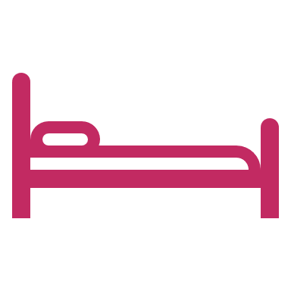
Sleep

Here are the basics – choose always / often /sometimes / rarely / never from the dropdown menu:
I sleep for 8+ hours. | Choose an item.
I go to bed and get up about the same time every day. | Choose an item.
I don’t drink coffee or other high-caffeine drinks after 4pm. | Choose an item.
I put away my mobile phone and other electronic devices at least 30 minutes before I go to bed. | Choose an item.
I have some relaxation techniques that I use before I go to bed. | Choose an item.

Diet

Here are the basics – choose always / often / sometimes / rarely / never from the dropdown menu:

I eat breakfast (tea or coffee on its own doesn’t count). | Choose an item.
I have at least 5 portions of fruit and vegetables each day. | Choose an item.
I avoid snacking on sugary or salty foods. | Choose an item.
I avoid fast-food. | Choose an item.
I drink between 6-8 glasses of water a day. | Choose an item.

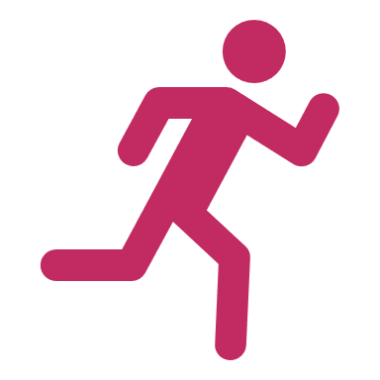
Exercise

Here are the basics – choose always / often / sometimes / rarely / never from the dropdown menu:
I exercise for at least 50 minutes each day (moderate exercise like walking counts). | Choose an item.
I take the stairs rather than use a lift whenever I can. | Choose an item.
I help out with household chores (a really good way of getting more exercise). | Choose an item.
I move about at lunchtime – walking or playing sports. | Choose an item.
I make my bed in the morning (a great way of getting muscles moving first thing). | Choose an item.

Where possible, you should aim to achieve always / often in every section across the three categories. These actions / behaviours will help build your physical resilience which is extremely important for the exam season. Don’t worry if you’re not doing all (or any) of these things at the moment, try focusing on one at a time to build your resilience.

Here are some useful websites:
Lifestyle | Health for Teens Lots of useful information – start in the lifestyle section.
Top healthy eating tips for teenagers - British Nutrition Foundation Reliable, science-based information for a healthy, sustainable diet.
Home - Teen Sleep Hub A wealth of information about sleep and a quiz to find out if you are a lark or an owl.
Physical activity guidelines for children and young people - NHS (www.nhs.uk) Physical activity guidelines for young people.

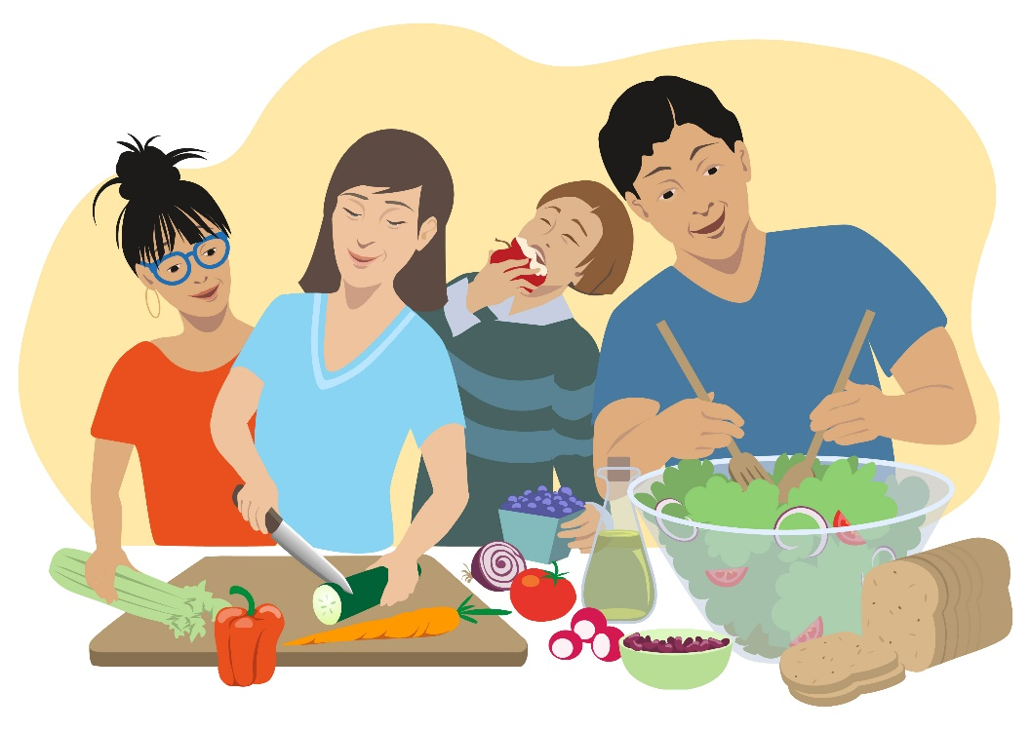

What actually is stress?
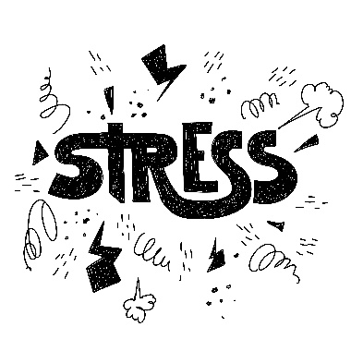

Stress is any type of change that causes physical, emotional or psychological strain to your body. These changes are called stressors. Examples of stressors are exams, getting a poor grade, falling out with a friend – these may all have a physical effect on your body.

A stressful event triggers a cascade of hormones, including adrenaline and cortisol, that surge through your bloodstream. The hormones cause your heart to beat faster and prompt your body to produce energy, focus attention and prepare muscles for movement. Externally your breathing becomes rapid, you may begin to sweat and your stomach may begin to churn.

Ways of dealing with stress: understanding why we feel anxious

Exam stress usually arises from four different causes. Think carefully about each cause – which apply to you?

- External pressures – this is when you feel pressured by the expectations of teachers or family. You have targets you should be meeting. Everyone wants to know how the revision is going! | Choose an item.
- Internal pressures – these are connected with what will happen after the exams – will you be able to get into sixth form, college or start an apprenticeship? The results of the exams may prevent you from doing what you want in terms of career or education. | Choose an item.
- The pressure of competition – you feel you are in competition with your peers and your achievements will be judged against theirs. | Choose an item.
- You haven’t worked hard enough – you feel unprepared. Maybe you haven’t worked hard enough, or there have been things in your life that have made it difficult to prepare as you would have liked to. | Choose an item.

Understanding the cause(s) of your stress is the first step to dealing with it. The second step is to share your feelings (remember this from Felicity’s video). Confide in someone you trust – parents / carers, teachers or a friend. Be honest about the way you’re feeling and why. While they may not have all the answers – they may have some suggestions which will help your situation.
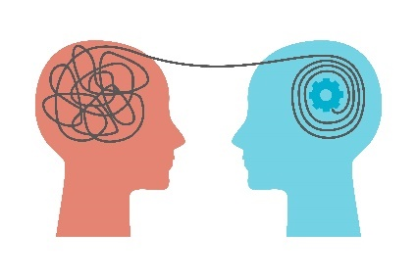

Ways of dealing with stress: practising breathing exercises
Being in control of your breathing will help with your overall self-regulation. So, start practising breathing exercises and do them every day. That way, when you are feeling stressed, they will be the first tool in your stress-busting toolkit.
Here’s an easy technique for beginners.
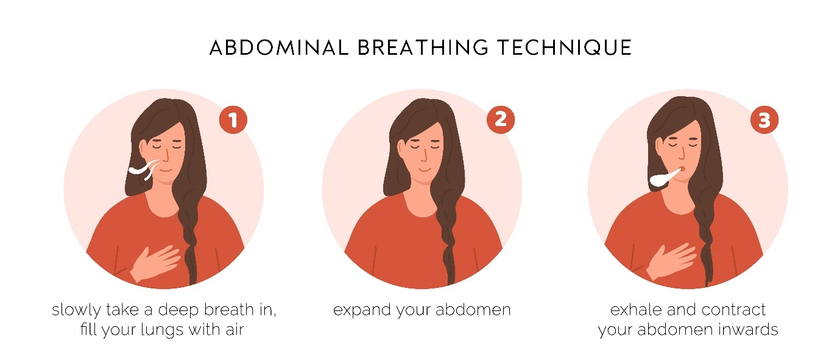

More information can be found on the following sites:

Relaxation Exercises: Breathing Basics (for Teens) - Nemours KidsHealth
Breathing exercises for stress - NHS (www.nhs.uk)

Ways of dealing with stress: making a calm box

In the video, Felicity described making a calm box. This is a great tool to help you self-regulate and calm down in times of stress. Remember to think about the senses. Here are some ideas from our team.

Helen’s calm box
- Photograph of her children
- Noise cancelling headphones (she’s most calm when it’s completely quiet)
- Tic-tacs
- Essential oil: Ylang Ylang
- Hand cream.

Bob’s calm box
- Postcard of Loch Lomond
- A link to Ocean waves sounds
- Liquorice
- Vanilla pods
- Stress ball.

Liz’s calm box
- Snow globe
- A mouth organ
- Jelly Babies
- Sunscreen
- Kanga, soft toy (from Winnie the Pooh).

Now make your own calm box. What will you include:

 | Write here…
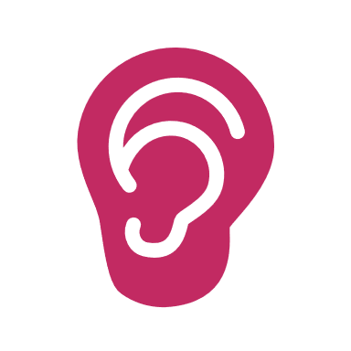 | Write here…
 | Write here…
 | Write here…
 | Write here…
Your To Do List
This module is personal to you – we have focused on ways that you can look after yourself in the exam period and also in the run up to the exams. You should start as soon as you possibly can – but definitely during Year 11.

Below you will find a list of things it might be good to have in place. The ideas come from the video, from these pages and include some other tips we have picked up in our research. Read the list carefully and add any actions that are relevant to your ‘to-do-list’ on the next page.

- Share your feelings about the exams with a parent / carer, teacher, friend (they will want to know how you are feeling)
- Be organised – plan your revision programme carefully – use the skills you have learnt in this programme
- Be prepared – ask your teachers for copies of previous exam papers, make sure you have exam dates on your calendar, know exactly what to expect
- Look after your body: sleep well
- Look after your body: eat well and keep hydrated
- Look after your body: exercise and move about as much as you can
- Understand the reasons for how you feel
- Practise breathing exercises
- Make a calm box
- Keep things in perspective: make a list of things you would like to do in life which don’t rely on exam results
- Return to modules in this programme which you feel will be most useful to you.

My To Do List
Now complete the list below with the ideas that will be most helpful to you.
1. | Write here…
2. | Write here…
3. | Write here…
4. | Write here…
5. | Write here…
6. | Write here…
7. | Write here…
8. | Write here…
9. | Write here…
10. | Write here…

Useful websites

More information can be found on the following sites:
Exam Stress | How To Deal with Exam Stress | YoungMinds – you will remember this is the one Felicity recommended.
Exams: how to look after yourself - BBC Bitesize
Wellbeing guide for GCSE pupils (charliewaller.org) – a useful resource you can download from the website. There is a similar resource you can download and email to your parents/carers.

We hope you have enjoyed this Looking After Yourself module and you have found the activities useful.

This is the final module in The Study Skills Programme. We would like to thank you for working through all the activities. We hope that you have found them helpful and we wish you every success in your exams.

