Research skills

- Save this Word Document to your own computer or device. It’s your workbook and no one else will have access to it.
- Work through the different activities at your own pace – there are videos to watch and activities to develop and enhance your research skills.
- Remember to take regular breaks.
- When you have finished each part, save your work, take a break and when you are ready, move on to the next section.

We are really keen for you to be involved, so as you work through this module you will see the following icons to let you know what to do.

 | Read |  | Watch
 | Listen |  | Complete

Good luck and enjoy!

Introduction and welcome

Welcome to the research skills module.
In this module, we’ll take you through the basics and give you opportunities to practise your research skills.

Watch, listen and take part to get best possible experience from this module. We’re with you every step of the way.

Contents

- Introduction – a guide which takes you through the process of identifying exactly what you want to find out, explains why it is so important to avoid plagiarism and considers the different sources you might want to use for your research.
- Evaluating sources – from books to websites to journals, it’s important to recognise the pros and cons of different sources. In the section, we take you through a number of key questions to ask as you interrogate your research sources.
- Bibliographies and referencing – how to put together a list of sources for the end of your project, essay and report and how to reference a source within your own writing.

An introduction to Research Skills

You will need paper and a pen for this video.

Watch An introduction to research skills here by opening the hyperlink. Remember to put the video on full screen .

In this introductory video, Helen identifies a number of sources that you might use for research and gives advice on how to avoid plagiarism by following two simple rules. She leaves you with a task focusing on the positives and negatives of different research sources.

Plagiarism
This means presenting someone else’s ideas or work as your own. This can happen without you realising – so take care!

Follow two simple rules to avoid plagiarism:

- Keep a note of your sources as you research – make sure you know which ideas come from which resource.
- Write notes in your own words – don’t copy. If the writer has a brilliant idea and has written it concisely – use quotation marks to indicate it is not your own words (and reference it – see final video).

What are the pros and cons of different sources? Think carefully- an example has been included for the first source but do add more. A number of suggestions have been listed at the end of the activity. Click in the boxes to add your ideas.

Books
Pros | Cons
Written by experts – information likely to be of value | Finding books is time-consuming

Websites

Pros | Cons
Write here… | Write here…

Wikipedia (a website)

Pros | Cons
Write here… | Write here…

Journals
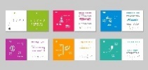
Pros | Cons
Write here… | Write here…

Images and cartoons
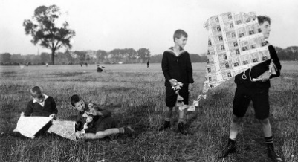
Pros | Cons
Write here… | Write here…

Newspapers
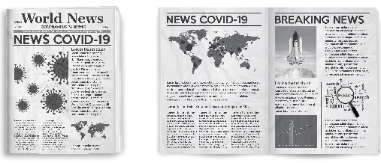
Pros | Cons
Write here… | Write here…

YouTube
Pros | Cons
Write here… | Write here…

Documentaries
Pros | Cons
Write here… | Write here…

Run out of ideas? See where the following pros and cons belong.
- Reliable  - Unlikely to be biased  - Easy to navigate  - Informative  - Current  - Multi-media  - Academic  - Can provide great background information  - Factual  - Often written to answer an academic question | - Can be too specific  - Hard to access  - Anyone can contribute and write and edit articles  - No formal editors or review process  - Constantly changing  - Can be biased  - Need to check reliability  - Can be outdated  - Time consuming  - Limited information

Evaluating sources

Watch Evaluating sources here by opening the hyperlink. Remember to put the video on full screen .

In this video, Helen gave a list of questions to ask about sources (and websites in particular). Here they are:

- What does the title tell you about the content?
- Is the author named? Is the author an expert in this field?
- What date was the source written or published?
- Who is the intended audience?
- How relevant is the resource for your research purposes?
- Does the author provide a bibliography or references to show their sources?

Evaluate the sources
Below, you will find 4 sources about writing to describe. Answer the questions for each source and then rate them according to how useful they would be to a student preparing for their GCSE English Language.
Use a 5-star rating, where 1 star is not at all useful and 5 stars is very useful.

The Art of Descriptive Writing
Open the link below and read the content. Then, answer the questions in the box below.
https://www.novel-writing-help.com/descriptive-writing.html
Link accessed and valid on 04.08.21
Question | Your answer
- What does the title tell you about the content? | Click or tap here to enter text.
- Is the author named? Are they an expert in the field? | Click or tap here to enter text.
- What date was the source written or published? | Click or tap here to enter text.
- Who is the intended audience? | Click or tap here to enter text.
- How relevant is the source to your research purpose? | Click or tap here to enter text.
- Does the author provide a bibliography or references to show their sources? | Click or tap here to enter text.
How many stars? | Choose an item.
What is descriptive writing and how can it improve your essay?
Download the accompanying document to use for this exercise from the website- ‘Mr Hanson’s Descriptive Writing Structure’

Question | Your answer
- What does the title tell you about the content? | Click or tap here to enter text.
- Is the author named? Are they an expert in the field? | Click or tap here to enter text.
- What date was the source written or published? | Click or tap here to enter text.
- Who is the intended audience? | Click or tap here to enter text.
- How relevant is the source to your research purpose? | Click or tap here to enter text.
- Does the author provide a bibliography or references to show their sources? | Click or tap here to enter text.
How many stars? | Choose an item.

Descriptive writing
2 Grade 9 Creative Writing Examples – Miss Huttlestone's GCSE English (wordpress.com)
Link accessed and valid on 04.08.21
Question | Your answer
- What does the title tell you about the content? | Click or tap here to enter text.
- Is the author named? Are they an expert in the field? | Click or tap here to enter text.
- What date was the source written or published? | Click or tap here to enter text.
- Who is the intended audience? | Click or tap here to enter text.
- How relevant is the source to your research purpose? | Click or tap here to enter text.
- Does the author provide a bibliography or references to show their sources? | Click or tap here to enter text.
How many stars? | Choose an item.

Descriptive writing
https://www.bbc.co.uk/bitesize/guides/zpxcwmn
Link accessed and valid on 04.08.21

Question | Your answer
- What does the title tell you about the content? | Click or tap here to enter text.
- Is the author named? Are they an expert in the field? | Click or tap here to enter text.
- What date was the source written or published? | Click or tap here to enter text.
- Who is the intended audience? | Click or tap here to enter text.
- How relevant is the source to your research purpose? | Click or tap here to enter text.
- Does the author provide a bibliography or references to show their sources? | Click or tap here to enter text.
How many stars? | Choose an item.

Bibliographies and referencing

Watch Bibliographies and referencing here by opening the hyperlink. Remember to put the video on full screen .

Bibliography: a list of sources you used when writing an academic essay or report. It is also used to describe a list of books or articles an author has published on a specific subject.

In the video, Helen explained how to write a bibliography and how to reference sources in your essays, reports and projects.
Here are the examples she provided:

Bibliography: books

Bibliography: journals and websites

Two examples of referencing

Practising writing a bibliography
Here are three books – for each book there is a cover and publication details. Complete the details for a bibliography under each one.
Book 1

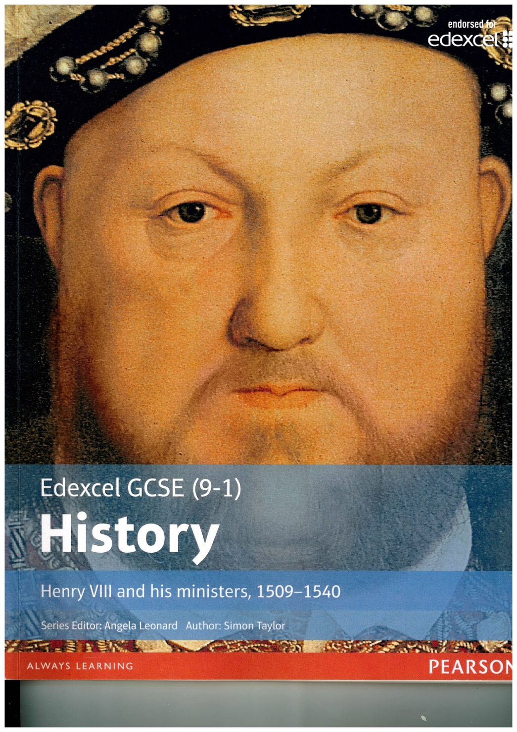
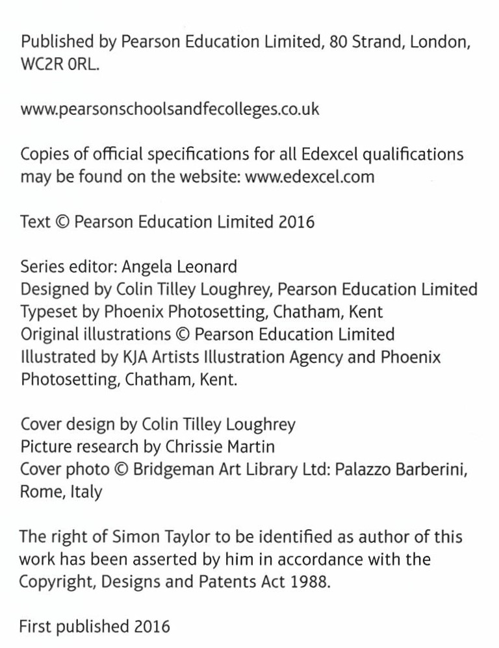

Write the details for your bibliography here:
Click or tap here to enter text.

Book 2
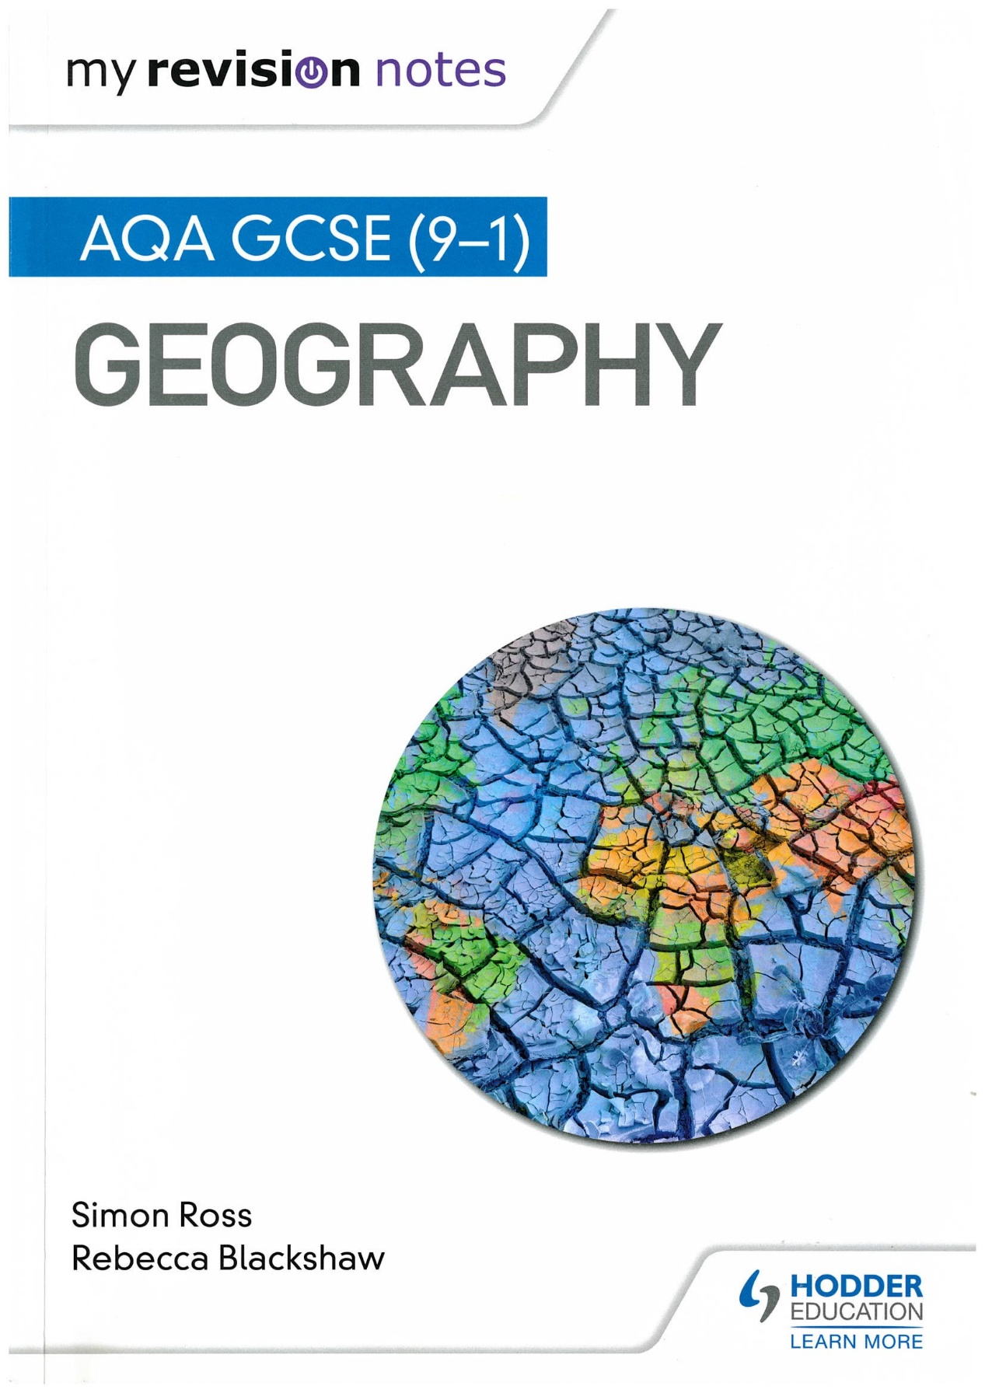

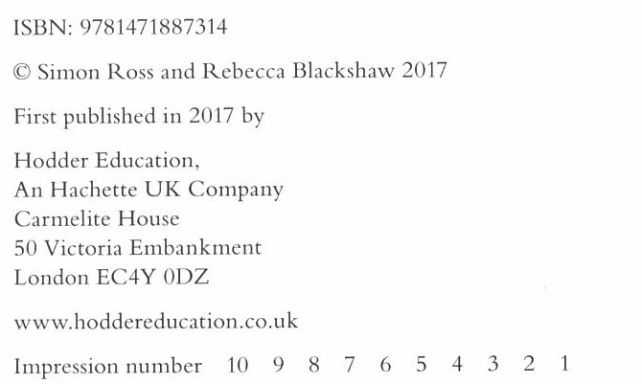

Write the details for your bibliography here:
Click or tap here to enter text.

Book 3
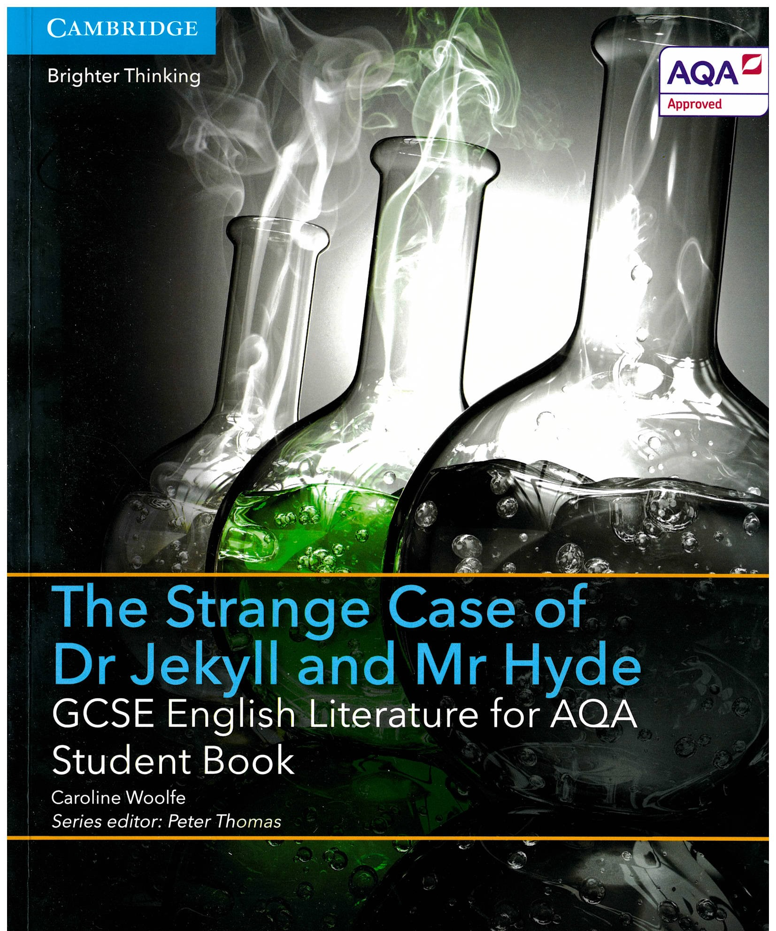

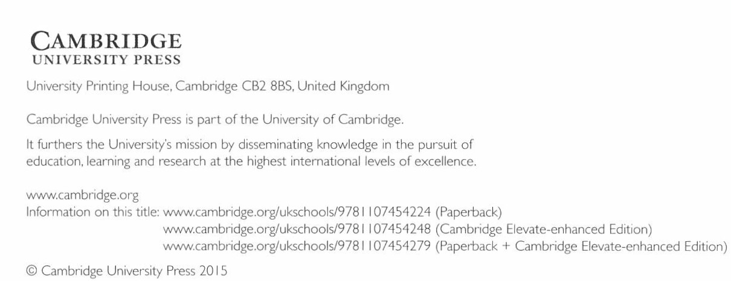

Write the details for your bibliography here:
Click or tap here to enter text.

Bringing it all together
There are several unsolved mysteries in our world. Here are some of them:
- The Bermuda Triangle
- The lost colony of Roanoke
- The disappearance of Malaysian Airlines Flight 370
- What happened to Amelia Earhart?

Choose one of these mysteries, or another topic of your choice, and spend 20-30 minutes researching it on the internet - aim to use at least 3 sources. Make notes and keep a draft bibliography.

Write a short report on your findings (250-500 words) – reference your sources in the body of your text (remember Macbeth) and include at least one quotation from a source.

Then write your bibliography.

Example: Katie’s Research and Report
Belmez Faces: Mystery of the People in the Floor
Notes
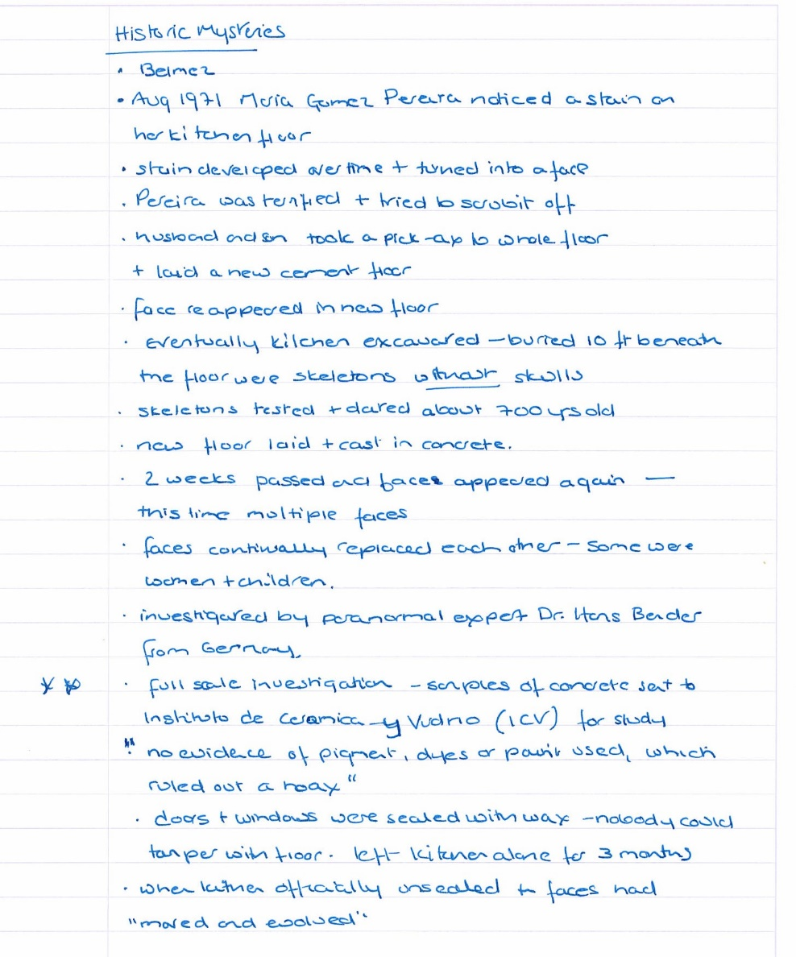

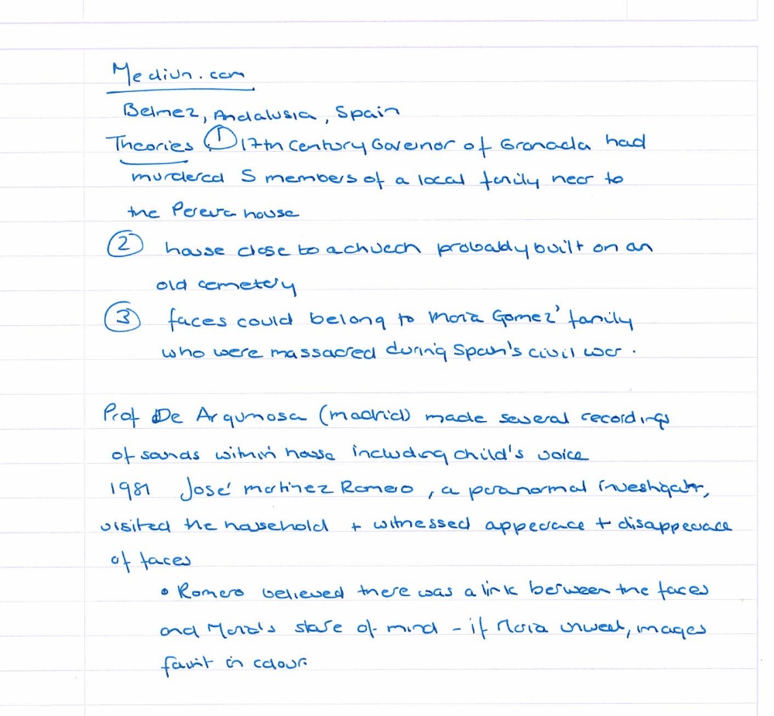

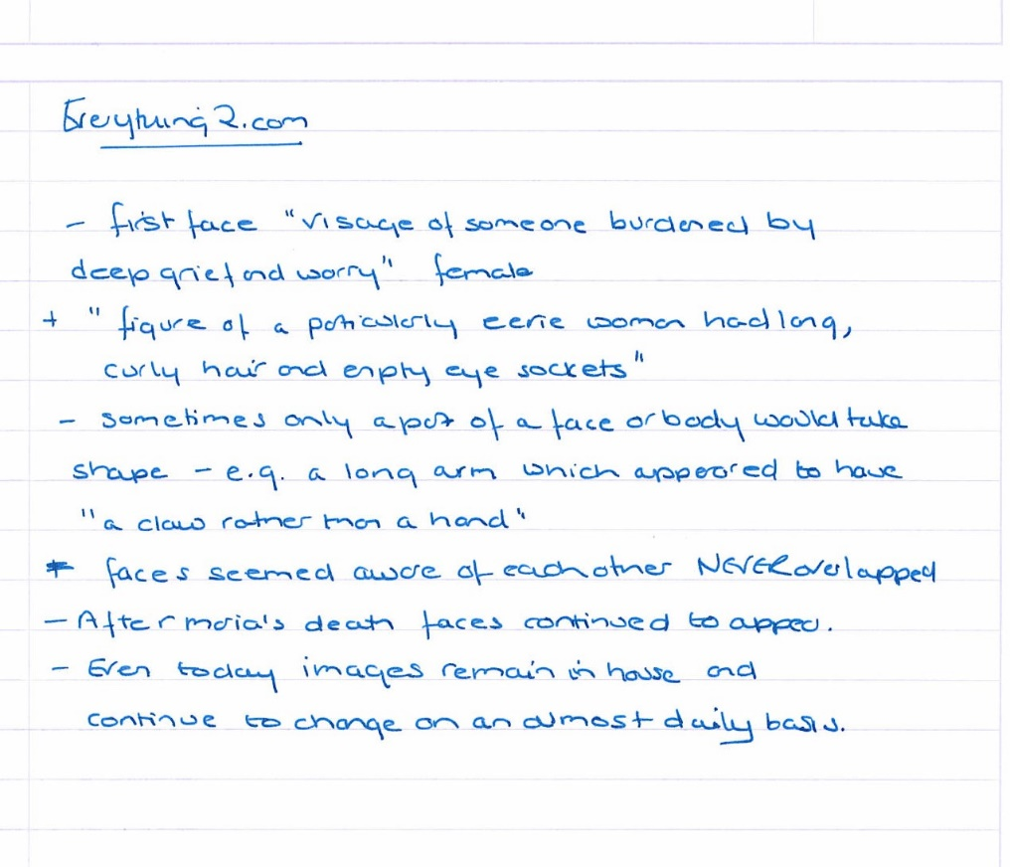

Belmez Faces: Mystery of the People in the Floor
by Katie Steben

Overview
The faces in the floor mystery occurred in Belmez, a small village in Andalusia in Spain at the home of Maria Gomez Pereira in 1971. A stain on her kitchen floor turned over time into a face and the further faces appeared. Successive investigations found that this was not a hoax.

The People in the Floor
When Maria Gomez Pereira first noticed the face, she was terrified and tried to scrub it off. It was reported to be a female ‘the visage of someone burdened by deep grief and worry’ (https://medium.com/our-weird-wonderful-world/the-people-in-the-floor KS 04.08.21). The face reappeared and Pereira’s husband and son dug up the floor and laid a new cement floor. However, the faces reappeared.
The local Mayor ordered the kitchen to be excavated and skeletons were found 10 feet beneath the floor without skulls. The skeletons were taken away for testing and found to be 700 years old. A new concrete floor was laid. Two weeks passed and then multiple faces appeared. This time the faces continually changed and sometimes they were the faces of women and children. The Everything2.com website, gives detailed descriptions of some of the faces, including a ‘figure of a particularly eerie woman had long curly hair and empty eye sockets’ and also mentions other body parts appearing including a long arm which appeared to have ‘a claw rather than a hand’ (https://Everything2.com KS 04.08.21)

Investigations
Several official investigations took place into the phenomena. The Historic Mysteries site mentions a paranormal expert, Dr Hans Bender, from Germany and the samples of concrete being sent to the Instituto de Ceramica y Virdno (ICV) for study. The Medium.com site mentions a Professor de Argumosa from Madrid who made several recordings of sounds within the house including a child’s voice. The same website describes another paranormal investigator visiting the house in 1981 and witnessing the appearance and disappearance of the faces. This investigator believed that there was a link between the faces and Maria’s state of mind as if she was unwell, the images seemed fainter in colour.

Theories
Several theories are put forward in all three websites. Firstly, a 17th Governor of Granada had murdered five members of a local family near to the Pereira house; secondly, the house was close to a church and therefore probably built on a local cemetery; and finally, the faces belonged to Maria Gomez’s family who were massacred during the Spanish Civil War.

Conclusion
The Historic Mysteries site quotes the ICV report: ‘no evidence of pigment, dyes or paint used, which rules out a hoax’ (https://medium.com/our-weird-wonderful-world KS 04.08.21). However, I was not able to find this report online or any newspaper reports that verified the stories. I did find images but they were all very different and again it was difficult to verify where they came from or their authenticity. On balance, I believe there is some truth in the story but much exaggeration too.
485 words

Bibliography
Belmez Faces: Mystery of the People in the Floor | Historic Mysteries (KS 08.21)
The People in the floor. Digging into the story of the Faces of… | by Amber Blaize | Our Weird & Wonderful World | Medium (KS 08.21)
Faces on the Kitchen Floor: Belmez, Spain, 1971 - Everything2.com (KS 08.21)

Your report
Write your title here

Notes: resource 1
Remember to make a draft bibliography
Write your notes here

Notes: resource 2
Write your notes here

Notes: resource 3
Write your notes here

Report
Write your report here

Bibliography
Write your bibliography here

REMEMBER!

Before starting your research think carefully about what you want to find out. | Decide what type of sources you will use to suit your purpose. | Follow the two rules to avoid plagiarism.
Evaluate your sources. | Make a draft bibliography. | Remember to reference ideas and quotations in your essay, report or project. Write your final bibliography.

We hope you have enjoyed this research skills module and that you have found the activities useful. Have a look at Critical Thinking next.

