Critical Thinking

- Save this Word Document to your own computer or device. It’s your workbook and no one else will have access to it.
- Work through the different activities at your own pace – there are videos to watch and activities to develop and enhance your critical thinking skills.
- Remember to take regular breaks.
- When you have finished each part, save your work, take a break and when you are ready, move on to the next section.

We are really keen for you to be involved, so as you work through this module you will see the following icons to let you know what to do.

 | Read |  | Watch
 | Listen |  | Complete

Good luck and enjoy!

Introduction and welcome

Welcome to the critical thinking module.
In this module, we’ll take you through the basics and give you opportunities to practise your critical thinking skills.

Watch, listen and take part to get the best possible experience from this module. We’re with you every step of the way.

Contents

- Introduction – Annabel introduces critical thinking in the video. She emphasises the importance of asking questions and identifies 5 things we do every day which contribute to critical thinking (sometimes without knowing it!)
- Information and argument – critical thinking begins with critical reading. Here you will identify bias and consider how opinions can be presented as facts.
- Analysis and evaluation – how to operate as a critical thinking detective. Analysis requires you to take things apart and examine them closely (you probably have carried out this process in English lessons). Evaluation requires you to examine the pros and cons of an idea, belief or argument.
- Problem solving – In this section, you’ll be provided with a 4-point problem solving strategy and see it used in a very practical scenario.

Glossary
This glossary provides details of the key words used in this module.
analyse | To analyse is to examine something in detail – break it down into its component parts.
bias | Bias means that a person prefers an idea and possibly does not give equal chance to a different idea.
correlation | In statistics, correlation is a way to indicate how closely related two sets of data are. This does not mean that one causes the other; in fact, it is very possible that there is a third factor involved. Correlation usually has one of two directions - positive or negative (you’ll know this from using scatter diagrams in Maths).
evaluate | To judge something in a thoughtful and careful way.
inference (infer) | Inference is the process of drawing a conclusion based on the available evidence plus your previous knowledge and experience. We sometimes say inference is reading between the lines.
objectivity | If you look at something objectively, you consider it based solely on the facts and are not influenced by any personal feelings or beliefs.

An introduction to Critical Thinking

Watch An introduction to critical thinking here by opening the hyperlink. Remember to put the video on full screen .

In this introductory video, Annabel explores how we use critical thinking every day. There are five things we do all the time that contribute to thinking critically: observation, inference, analysis, communication and problem-solving. This module is about transferring these skills to your studies and becoming more aware of when you are using them.

Approaching information and arguments critically

You will need a pen and paper for this video.

Watch Approaching information and arguments critically here by opening the hyperlink. Remember to put the video on full screen .

In the video, Jack showed a short one-paragraph argument from 501 Challenging Logic and Reasoning Problems.

Here are three more problems taken from the same resource. Read each paragraph carefully and decide which of the five given statements is best supported by the paragraph.
Remember – read critically!
Answers are at the end of the workbook.

Paragraph 1
There are no effective boundaries when it comes to pollutants. Studies have shown that toxic insecticides that have been banned in many countries are riding the wind from countries where they remain legal. Compounds such as DDT and toxaphene have been found in remote places like the Yukon and other Arctic regions.

This paragraph best supports the statement that
- Toxic insecticides such as DDT have not been banned throughout the world.
- More pollutants find their way into polar climates than they do into warmer areas.
- Studies have proven that many countries have ignored their own anti-pollution laws.
- DDT and toxaphene are the two most toxic insecticides in the world.
- Even a worldwide ban on toxic insecticides would not stop the spread of DDT pollution.

Paragraph 2
Most Reality TV centres on two common motivators: fame and money. The shows transform waiters, hairdressers, investment bankers and teachers to name but a few, from obscure figures to household names. A lucky few successfully parlay their fifteen minutes of fame into celebrity. The luckiest stars of Reality TV also reap huge financial rewards for acts including eating large insects, marrying someone they barely know, and revealing their innermost thoughts to millions of people.

This paragraph best supports the statement that
- The stars of Reality TV are interested in being rich and famous.
- Reality TV is the best thing that has happened to network television in a long time.
- For Reality TV stars, fame will last only as long as their particular television show.
- Traditional dramas and sitcoms are being replaced by Reality TV programming at an alarming rate.
- Reality TV shows represent a new wave of sensationalistic, low-quality programming.

Paragraph 3
The image of a knitter as an older woman sitting in a comfortable, old-fashioned living room with a basket of yarn at her feet and a bun in her hair is one of the past. As knitting continues to become more popular and increasingly trendy, it is much more difficult to describe the average knitter. Knitters today might be 18, 28, 40 or 65. They might live in a big urban centre and take classes in a knitting shop that doubles as a café or they may gather in suburban coffee shops to support one another in knitting and other aspects of life. They could be college roommates knitting in their dorm room or two senior citizens knitting in a church hall. Even men are getting in on the act. It would be incredibly difficult to come up with an accurate profile of a contemporary knitter to replace that image of the old woman with the basket of yarn!

This paragraph best supports the statement that
- People are returning to knitting in an attempt to reconnect with simpler times.
- Knitting is now more of a group activity, as opposed to an individual hobby.
- Creating an accurate profile of a particular type of person depends on the people in the group having traits and characteristics in common.
- Today’s knitters are much less accomplished than knitters of the past.
- Young people are returning to knitting in record numbers.

Bias
As Jack explained, biased information is information from a particular perspective or point of view. It may be a personal opinion, a statement that has no factual basis, or it could be information that is prejudiced in favour of or against the topic.

Look at the following sentences. Decide which are biased and which are factual.

- The individual brought in for questioning had no police record. | Choose an item.
- The individual brought in for questioning was undoubtedly innocent. | Choose an item.
- The individual brought in for questioning had the look of a hardened criminal. | Choose an item.
- The violent tactics used by the thousands of angry protestors showed they were hell-bent on causing as much damage as they could. | Choose an item.
- Five people were arrested at the protest. Two protestors for smashing a window of a shop and the other three for assaulting police officers. | Choose an item.
- Wind farms out in the North Sea are beautiful - a lot more beautiful than oil rigs – and they don't cause accidents that can destroy people's lives. | Choose an item.
- Wind turbines ruin the countryside. They are unsightly and ruin our enjoyment of the rural landscape. | Choose an item.
- In 2019, the UK had 9,711 wind turbines – 7,779 onshore and 1,932 offshore turbines found around the coastlines of the UK. | Choose an item.

Write your own biased argument

In the video, Jack talked through the simple argument below which attempts to prove that football is a better sport than cricket.

Football is a much better sport than cricket. Let’s think objectively - this is because there is so much more action in football. In one football match, you will see so many skills: ball control, dribbling skills, passing accuracy and body control. And importantly, a footballer needs to be equipped with game intelligence skills: spatial awareness, tactical knowledge and on the spot risk assessments. Whereas, while there is no doubt a cricketer needs to be physically fit in order to bowl, bat and field, a footballer also needs endurance, balance and coordination, speed, strength and power. If you have any doubt left – think about how many times you will be on the edge of your seat in a football match, this level of excitement never happens in cricket!

Write your own short, biased argument using this structure:
- State your point of view (remember to present it as if it is a fact)
- Give reasons for this point of view
- Provide evidence to support your point of view (remember this does not need to be factual)
- Include a counter-argument and then dismiss it.

Use one of these topics or one of your own:
- Cricket is a much better sport than football.
- Music of the 2020s is better than classical music.
- All exams should be online – using a pen and paper is outdated.
- Video gaming should be considered a competitive sport.

Write your argument here

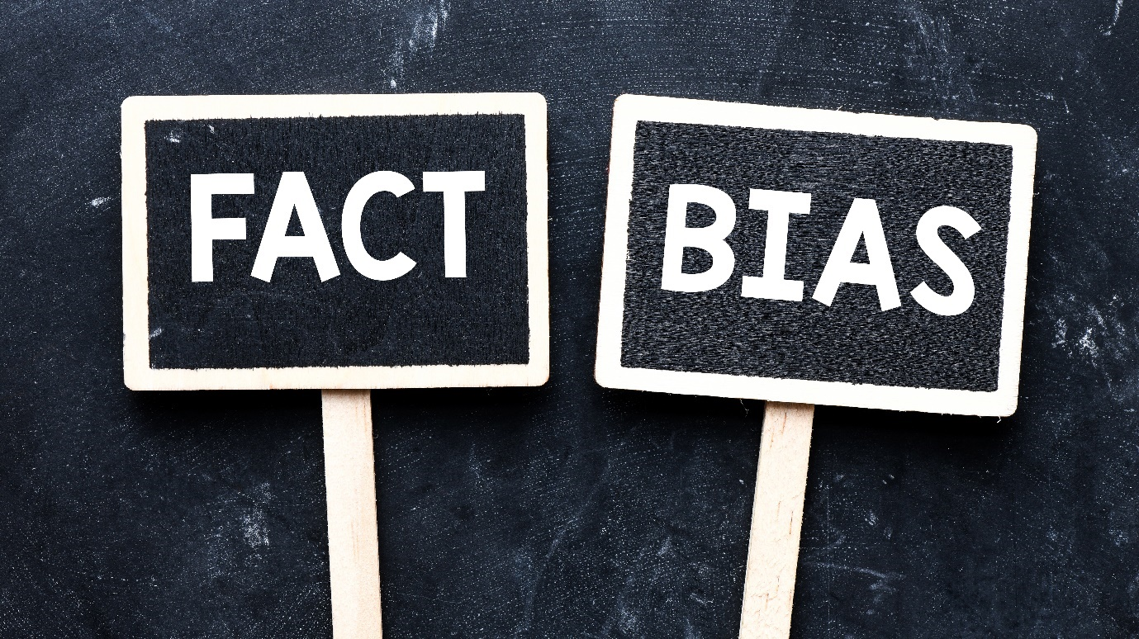

Full Fact
Full Fact are a team of independent fact checkers and campaigners who find, expose and counter the harm that misinformation does. They can be found at:
All of the facts we have checked - Full Fact
They also have a YouTube channel: Full Fact - YouTube.

Analysis and evaluation

In the next video, Helen will introduce the key critical thinking skill of analysis. This is where you examine something in detail – often breaking it down into its component parts. This is sometimes called ‘unpacking’ or deconstructing. Think of a burger! Burgers are usually built in layers – in order to understand what a burger is made up of (or how it ‘works’ in terms of taste) we will need to take apart the layers.
In the same way, you analyse language in English lessons when you study texts.

UK tax
In this video, you will be asked to consider a scenario relating to taxation. Here are a few useful facts which might help.

Types of tax
In the UK, we pay tax on any income over a certain amount. We also pay VAT (Value Added Tax), property and council tax, National Insurance, transport tax, energy tax and there is also an extra tax on food and drinks containing sugar.

What is the money used for?
The tax is used for a range of things: health and social care, education, defence, transport, public order and safety, housing and the environment. It is also used to pay off our national debt.

You will need a pen and paper for this video.

Watch Analysis and evaluation here by opening the hyperlink. Remember to put the video on full screen .

In the video, Helen spoke about objectivity and how your own personal feelings and beliefs can often prevent you from being objective. She gave the example that she felt strongly that zoos should be abolished. Here are the reasons she listed:

- From an animal rights standpoint, we do not have the right to breed, capture or confine animals.
- Animals in zoos suffer physically and psychologically from stress, boredom and confinement.
- Some zoos kill animals if they have a surplus.

From Helen’s perspective, these reasons form a conclusive argument that zoos should be abolished. However, in order to strengthen her skills of analysis and evaluation, she also provided some arguments for zoos.

- Zoos provide opportunities for people to be educated about animals and also to appreciate them. This in turn, motivates people to want to protect animals and their environment.
- Zoos often save endangered species by bringing them into a safe environment where they can be looked after.
- Zoos are a tradition in our country and they provide educational days out for all the family.

By looking at both sides of the argument, Helen can reach a conclusion. This doesn’t mean that she will change her point of view but it does mean that her perspective is more considered and thoughtful.

Try it yourself. Think of a topic about which you feel strongly. In the boxes below, write three reasons for your opinion.

My topic is: write here
- Write your reason here
- Write your reason here
- Write your reason here

Now, think of three arguments against your opinion. Write them in this box.

1. Write your reason here
2. Write your reason here
- Write your reason here

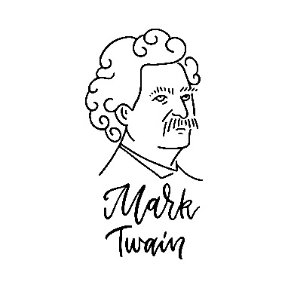
‘Lies, damned lies, and statistics.’

Interrogating numbers
Remember that numbers simply provide information. Their meaning and value lies in how we interpret them. Helen said we need to ask specific questions about numbers and statistics in order to understand their context. Can you remember the questions?
Write them in the box below:

❶ Write here
❷ Write here
❸ Write here
❹ Write here

Spurious correlations
Look up some more fascinating but absolutely pointless correlations on Tyler Vigen’s website Spurious Correlations (tylervigen.com) (accessed on 04.08.21).

Analysis and evaluation summary
- Use analytical skills to take information apart and explore it fully – ask questions, look for evidence and consider implications
- Evaluate – look at different points of view and remember to identify your own biases
- Question numbers and statistics – don’t just accept them.
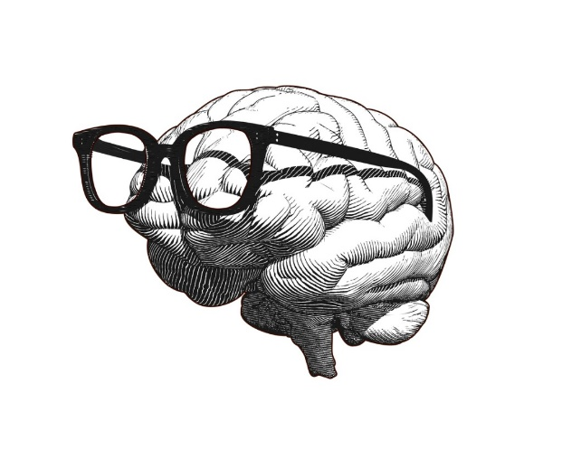

Problem solving

Watch Problem solving here by opening the hyperlink. Remember to put the video on full screen .
In this video, Jack offers a simple strategy for problem solving and applies it to a real life problem.
Problem solving strategy

- Identify the problem
- Come up with a variety of solutions
- Decide on the best solution and implement it
- Evaluate the success of your solution.

Remember if the solution doesn’t work, return to step 2 and review other solutions or start over completely.

Think of a problem you currently have – it could be personal or something to do with school / college or your studies. Use the template below to work through the problem. Working with a partner will help.

- Identify the problem – remember, it’s important at this stage to make sure you are identifying the actual problem so you may have to unpeel the layers of the situation (Kate thought she wasn’t talented enough, but in fact the problem was about the way she approached the course).

Write your problem here:

- Come up with a variety of solutions. Try to find as many solutions as possible – this is where working with a partner will really help.

Write your solutions here:

- Decide on the best solution and implement it.

Write what you are going to do here:

- Evaluate the success of your solution. Think about your problem – what has changed? Have you solved the problem?

Write an evaluation of your solution here:

Remember if the solution doesn’t work, return to step 2 and try other solutions or start over completely.

&

Figure It Out - The Art of Problem Solving | Shreyans Jain | TEDxDSCE - Bing video Shevran’s one answer to any problem is ‘we can figure it out’. Listen to his ideas about deconstructing and considering the consequences of every problem.
(accessed 04.08.21)

Give our youth the gift of problem solving | Hannah Hudson | TEDxChristchurch - Bing video
Hannah looks at global problems in terms of the Future Problem Solving Programme.
(accessed 04.08.21)

What Are Problem Solving Skills | Build Skills For Life And Work | Young Professional - Youth Employment UK
This website has some really good tips for problem solving and includes an article on Learning to become comfortable with being uncomfortable for people who think they ‘can’t do Maths’. Well worth a read.
(accessed 04.08.21)

Bringing it all together: remember we are always using our critical thinking skills
observe |  | infer
 | analyse
communicate |  | problem solve

ANSWERS

Answers to paragraphs in Approaching information and arguments critically (pages 6-8):
Paragraph 1: A
Paragraph 2: A
Paragraph 3: C

Answers to Bias activity in Approaching information and arguments critically (page 9):
- Factual
- Biased
- Biased
- Biased
- Factual
- Biased
- Biased
- Factual

We hope you have enjoyed this Critical Thinking module and that you have found the activities useful. Have a look at Presentation and Communication Skills next.

