Welcome to the programme

- Save this Word Document to your own computer or device. It’s your workbook and no one else will have access to it.
- Work through the different activities at your own pace – there are videos to watch, podcasts to listen to and numerous activities to help you improve and develop your study skills.
- Remember to take regular breaks.
- When you have finished each part, save your work, take a break and when you are ready, move on to the next section.
- We are really keen for you to be involved, so as you work through the modules you will see the following icons:
 | Read |  | Watch
 | Listen |  | Complete

Good luck and enjoy!

Getting started
This programme is designed to help you acquire new skills and improve those you already have so that you are able to achieve your potential in your course of study. There are eight modules to work through and each module has a series of activities for you to complete as well as a variety of videos and podcasts. It is possible to work through the programme in any order but do start by watching Annabel’s introduction and overview of each module.

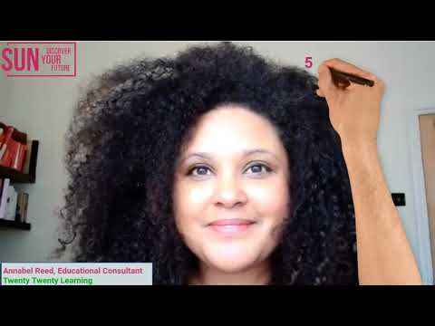
Click play on the video above or right-click this introduction link to watch in a new browser.

Planning your study skills programme
Let’s start by thinking about where you should start the programme. Answer the 8 questions that follow and then add up how many As, Bs, Cs, Ds you have chosen.

- Are you able to organise yourself effectively in terms of studying?
Choose an item.

- My study strengths are:
Choose an item.

- The areas I would like to develop are:
Choose an item.

- My attitude to learning and study is:
Choose an item.

- You have an exam tomorrow, what are you doing:
Choose an item.

- Today, you start researching for a presentation or essay. What’s your first step?
Choose an item.

- You haven’t been set any homework for the weekend. What do you do?
Choose an item.

- What motivates you to study?
Choose an item.

Mostly As
If you chose mostly As, you are already a confident and organised student. You have a range of strategies and techniques at your disposal. Do look at ‘Becoming an expert learner’ as it covers some interesting ideas and activities which may be new to you. The programme overall will enhance and develop your study skills and ensure you reach your potential.
Mostly Bs
Bs demonstrate you are able to study effectively most of the time. You are able to organise yourself and have some key strategies to use. Start by taking a look at ‘Developing a growth mindset’ in Module 1 and then the appropriate topic for your answer to question 3. You will then be well on the way to becoming a star student!
Mostly Cs
Mostly Cs suggest you are not really in control of your studies. You react to deadlines and pressures rather than adopting a pro-active approach. This may mean that you don’t always perform to your potential. Start by working through Module 1 ‘Becoming an Expert Learner’ to equip yourself with key skills which you can then build on.
Mostly Ds
At the moment, your answers suggest that you really don’t enjoy studying. Make a list of reasons why you are studying at the moment – think about the particular qualifications you are studying and how they will help you in the future. Then work through the programme module by module building up your skills. We really hope we can change your mind about studying.

What’s next?
We hope you have enjoyed the introduction and feel positive about the programme. The first module is Becoming an Expert Learner – we look forward to working with you on this first step of your learning journey.

