|  |
| --- |
| **Reading skills** |

|  |  |  |  |  |  |  |  |  |
| --- | --- | --- | --- | --- | --- | --- | --- | --- |
| * Save this Word Document to your own computer or device. It’s your workbook and no one else will have access to it. * Work through the different activities at your own pace – there are videos to watch, podcasts to listen to and numerous activities to develop and enhance your reading skills. * Remember to take regular breaks. * When you have finished each part, save your work, take a break and when you are ready, move on to the next section. * We are really keen for you to be involved, so as you work through this module you will see the following icons to let you know what to do.  |  |  |  |  | | --- | --- | --- | --- | | **Open book outline** | **Read** | **Vlog with solid fill** | **Watch** | | **Headphones with solid fill** | **Listen** | **Clipboard Checked outline** | **Complete** |   **Good luck and enjoy!** |

**Introduction and welcome**

Welcome to the reading module. Reading is something we do every day – sometimes without even thinking about it. However, reading as part of your studies can bring some challenges. Reading to support your studying needs to be purposeful as it is a key part of gaining knowledge as you work towards your qualifications. Some material may be difficult or unfamiliar; you may have to read to deadlines (for instance, with set texts) and you’ll need to engage with the content you read so that you are able to remember it.

In this section, we’ll look at how you change your reading style for different purposes; what to do with what you read (so the content stays in your memory) and look at some key questions to ask about a text.

Watch, listen and take part to get the best possible experience. We’re with you every step of the way.



**The four ways of reading**

Because we read quite a lot, it is sometimes hard to imagine that we actually (often automatically) have different styles of reading. Let’s do some experiments. Below you will find three extracts – each extract requires a different way of reading.

Look at **Extract One** below. Can you find the collective noun for sharks?

|  |
| --- |
| Type your answer here |

|  |  |  |  |
| --- | --- | --- | --- |
| **Extract One** | | | |
| **A glossary of collective nouns** | | | |
| **Noun** | **Collective noun** | **Noun** | **Collective noun** |
| alligators  ants  badgers  bears  bees  cats  eels | congregation  army  colony  sloth  swarm  glaring  bed | guinea pigs  hedgehogs  hummingbirds  sharks  sparrows  whales  wolves | herd  array  charm  shiver  host  school  pack |

Now, read **Extract Two**. Would this text help you research for an essay about the history of fishing?

|  |
| --- |
| Type your answer here and give your reasons |

|  |
| --- |
| **Extract Two** |
| When buying fresh fish there are a few things to look out for. With whole fish the eyes should be bright and clear, not dry. Inside the gills should be vivid pink or red, not brown. The skin should be vibrant and shiny and the flesh firm. Fillets or steaks of fish should be firm and translucent, without discolouration. Smell is also an excellent indicator of the freshness of a fish - it should smell of nothing but the sea. A fishy smell is a clear sign that the fish is past its best.  Frozen fish can be just as good, if not better, than all but the very freshest fish. Because it's often frozen quickly, it has less time to deteriorate than 'fresh' fish, which may be several days old by the time you buy it.  It's worth going to the trouble of finding a good fishmonger in your area, even if it's a bit of a trek, as there's no substitute for really fresh fish. |

Read **Extract three**. Would you like to read this novel?

|  |
| --- |
| Type your answer here and give your reasons |

|  |
| --- |
| **Extract Three** |
| I woke with a jolt and the icy coldness of the room hit me immediately. I felt the strangeness of the environment crawl over my skin as I struggled to piece together my surroundings. Although it was dark, I knew the room was totally unfamiliar – this was somewhere I hadn’t been before. I was laying on a thin mattress and as I tried to move, I felt a dull ache in my muscles. Fear, panic, and nausea swept through my body. Where was I? How did I get here? And, most importantly, how could I get out? |

****

Keep these activities in mind when watching this video. Annabel will show how you have used three of the four different styles of reading without thinking about it. You are well on the way to becoming a reading expert.

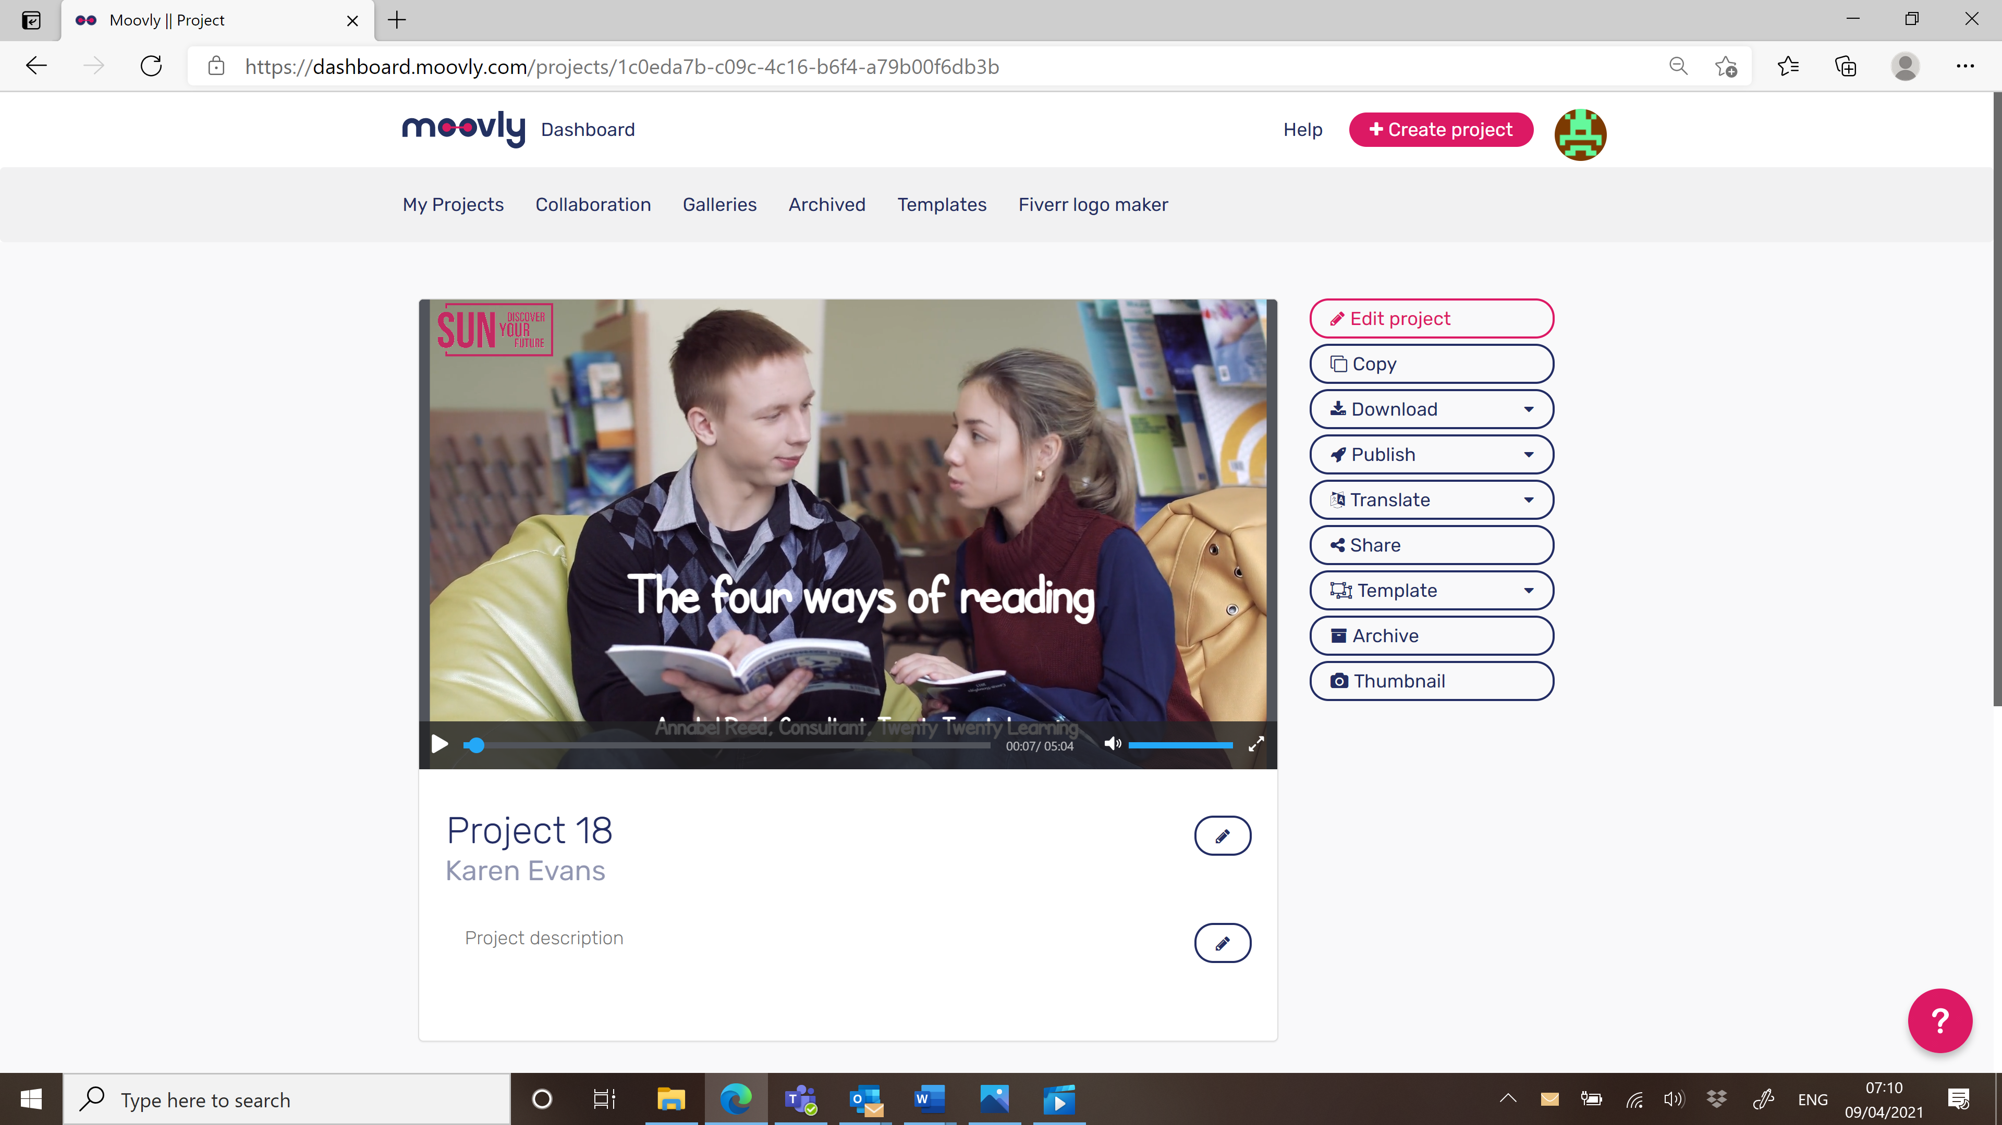

Watch The Four Ways of Reading [here](https://www.youtube.com/watch?v=wIkXujf_S1U) and open hyperlink. Remember to put the video on full screen 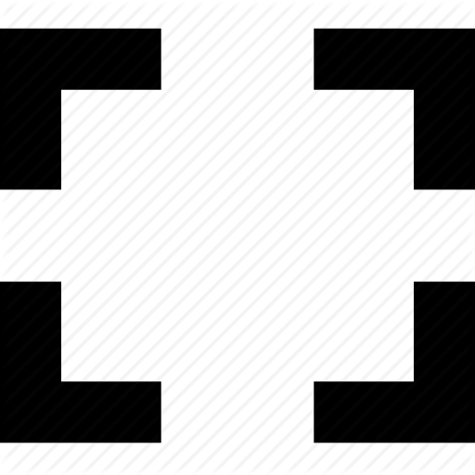.

**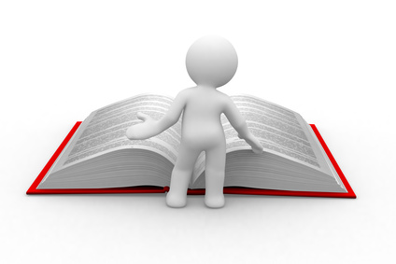**

****

**What have you been reading?**

Now you’ve watched the video, list the texts you have read over the past week and the style of reading you used in the table on the next page. Remember, this can include any text you have read – a menu, a text on your phone, an advert.

**Reading styles**

|  |  |
| --- | --- |
| **Continuous reading**  j0428113[1]  This type of reading happens when you’re not interrupted, and it’s usually used for longer texts or parts of texts. | **Skimming**  j0433938[1]  This is when you read something very quickly to get the gist of it. |
| **Close reading**  j0292112[1]  When you read something very carefully, stopping to think about what you have read or re-read sections again. | **Scanning**  bs01872_[1]  When you look for a particular piece of information – often your eye moves around the page instead of reading line by line. |

|  |  |
| --- | --- |
| **Text** | **Style of reading** |
| Text | Choose an item. |
| Text | Choose an item. |
| Text | Choose an item. |
| Text | Choose an item. |
| Text | Choose an item. |
| Text | Choose an item. |
| Text | Choose an item. |
| Text | Choose an item. |

Looking at the list, what’s the most common style you use?

|  |
| --- |
| **Type your answer here** |

**What happens in our brain when we read? Where to go next**



[Reading Can Change Your Brain! - Bing video](https://www.bing.com/videos/search?q=what+happens+in+our+brain+when+we+read&qpvt=what+happens+in+our+brain+when+we+read&view=detail&mid=70522C6D728BA708609370522C6D728BA7086093&&FORM=VRDGAR&ru=%2Fvideos%2Fsearch%3Fq%3Dwhat%2Bhappens%2Bin%2Bour%2Bbrain%2Bwhen%2Bwe%2Bread%26qpvt%3Dwhat%2Bhappens%2Bin%2Bour%2Bbrain%2Bwhen%2Bwe%2Bread%26FORM%3DVDRE)

[What Does Reading Do To Your Brain? These 5 Effects Are Pretty Astounding (bustle.com)](https://www.bustle.com/p/what-does-reading-do-to-your-brain-these-5-effects-are-pretty-astounding-74676)

**The first three questions to ask about a text**

When you look at a text for the first time, an expert reader will ask three basic questions:

* What type of text is it?
* Who is the intended audience?
* What is the purpose?

****

In this next video, Jack explores why these questions are so important.

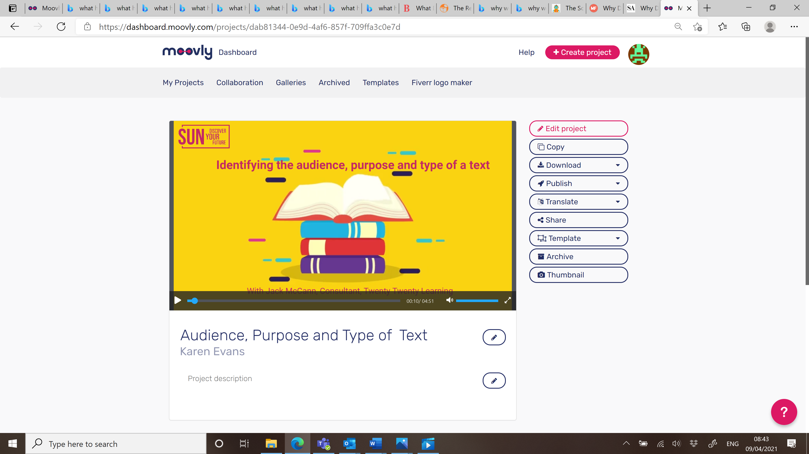

Watch the video [here](https://www.youtube.com/watch?v=hGP1dZu_9rA) and open hyperlink. Remember to put the video on full screen .

**Different types of text**

How many different text types can you think of? Jack named some in the video but there are more. Make a list below of 15 different types – the first one has been done for you.

|  |  |  |
| --- | --- | --- |
|  | **Type of text** | **Example** |
| 1. | **Magazine** | **Runner’s World** |
| 2. | Click or tap here to enter text. | Click or tap here to enter text. |
| 3. | Click or tap here to enter text. | Click or tap here to enter text. |
| 4. | Click or tap here to enter text. | Click or tap here to enter text. |
| 5. | Click or tap here to enter text. | Click or tap here to enter text. |
| 6. | Click or tap here to enter text. | Click or tap here to enter text. |
| 7. | Click or tap here to enter text. | Click or tap here to enter text. |
| 8. | Click or tap here to enter text. | Click or tap here to enter text. |
| 9. | Click or tap here to enter text. | Click or tap here to enter text. |
| 10. | Click or tap here to enter text. | Click or tap here to enter text. |
| 11. | Click or tap here to enter text. | Click or tap here to enter text. |
| 12. | Click or tap here to enter text. | Click or tap here to enter text. |
| 13. | Click or tap here to enter text. | Click or tap here to enter text. |
| 14. | Click or tap here to enter text. | Click or tap here to enter text. |
| 15. | Click or tap here to enter text. | Click or tap here to enter text. |

****

**Interrogating your texts**

Collect together five texts (remember, they don’t have to be books). In the grid below, complete the type, audience, and purpose of each text. The first row has been completed for you.

|  |  |  |  |
| --- | --- | --- | --- |
| **Title** | **Text type** | **Audience** | **Purpose** |
| **Runner’s World** | **Magazine** | **Runners of all ages** | **To inform** |
| Title | Text Type | Audience | Purpose |
| Title | Text Type | Audience | Purpose |
| Title | Text Type | Audience | Purpose |
| Title | Text Type | Audience | Purpose |

**What to do with what you read**

Now you know how you read, it’s critical to think about what you do with what you read. How do you make absolutely sure that what you’ve read stays in your memory, ready to be used in the next essay, assignment or exam?

****

In the next video, Helen looks at 3 activities. One activity you can do while you’re reading and the other two after you’ve read something.

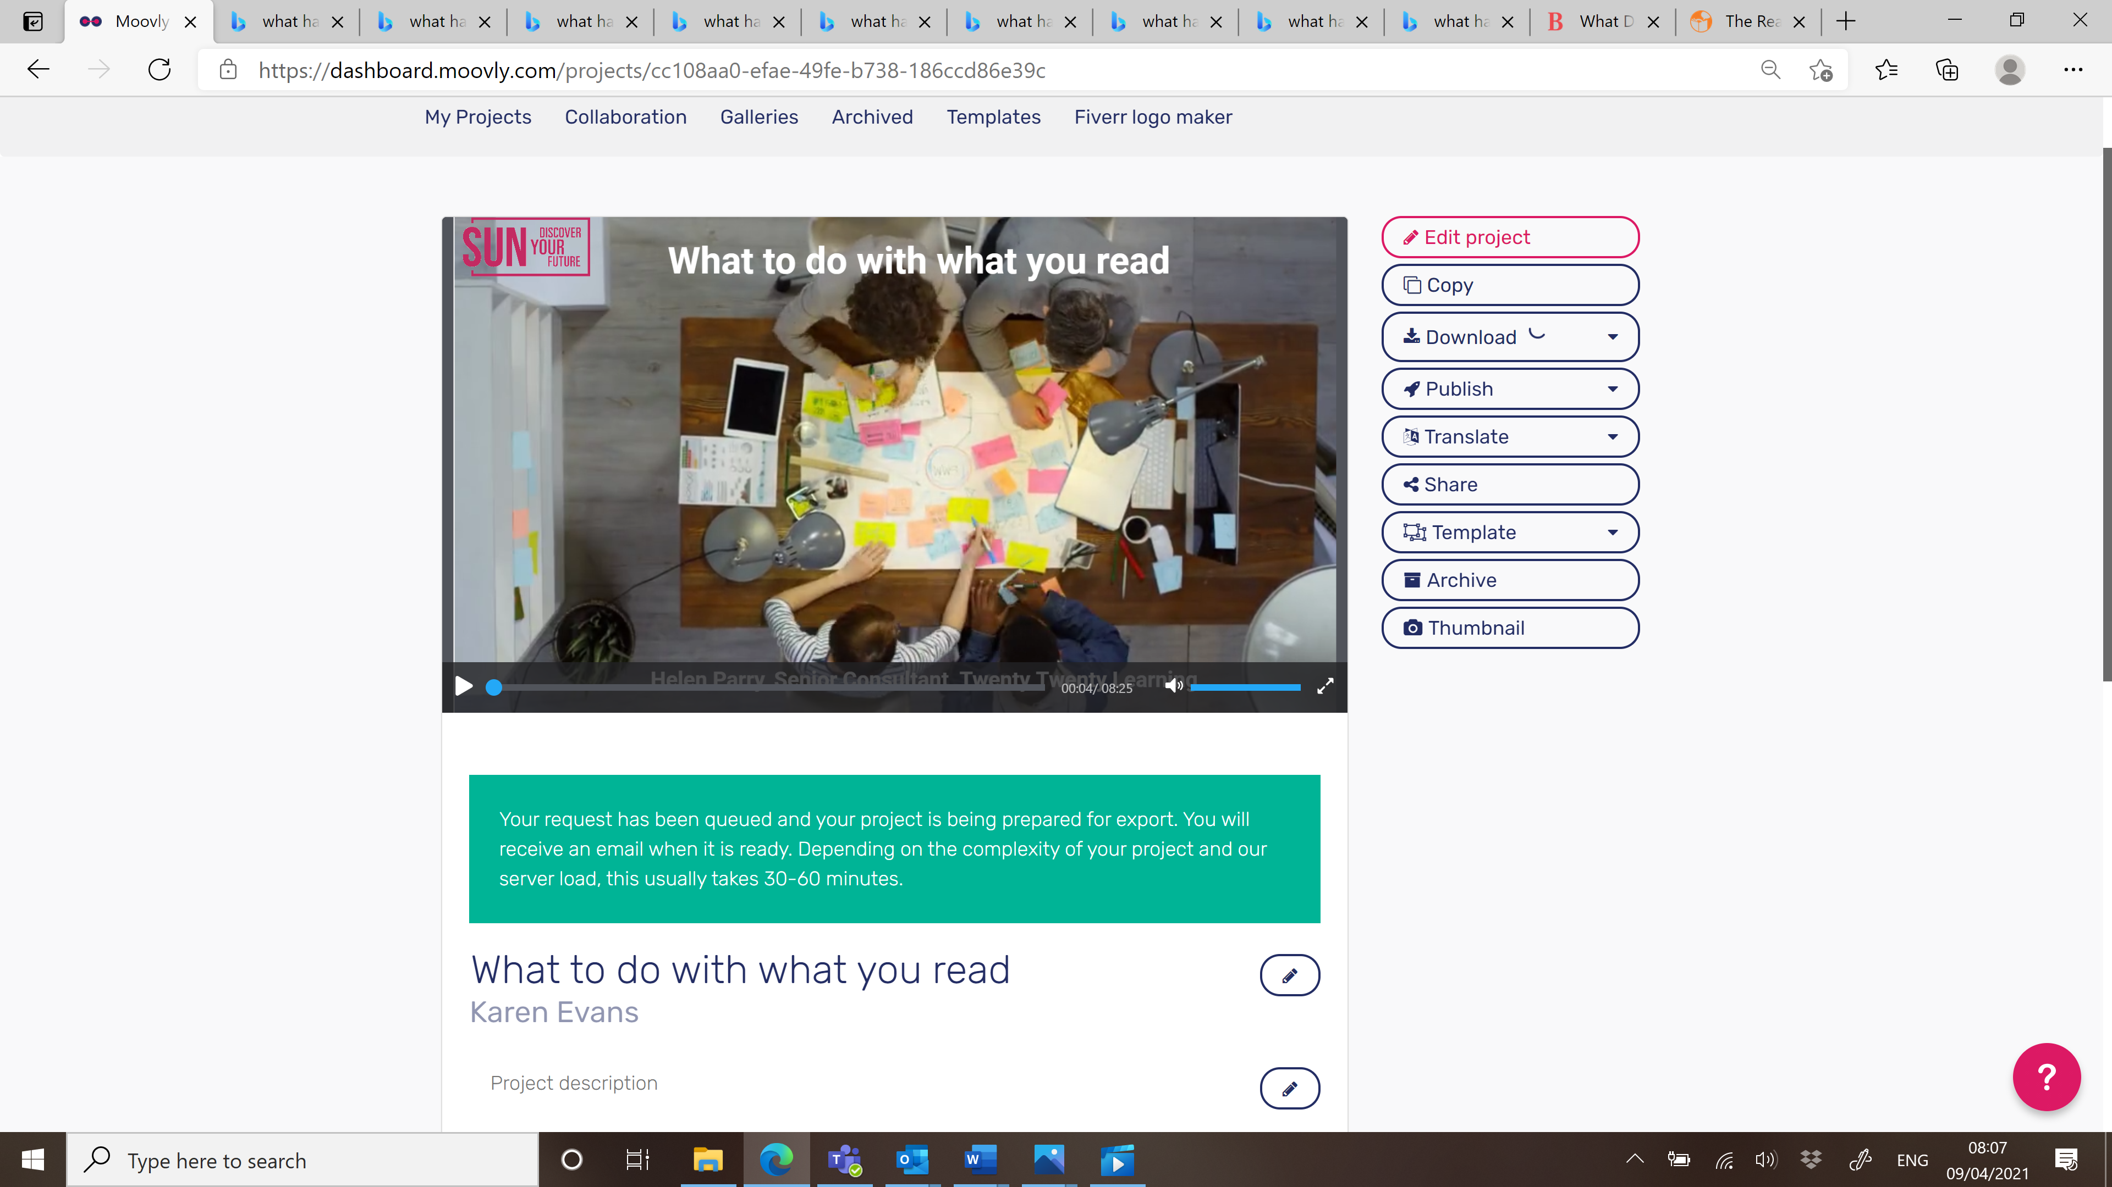

Watch the video [here](https://www.youtube.com/watch?v=j3xRktIaE0A) and open hyperlink. Remember to put the video on full screen .

**Annotating**

Annotating is where you make notes on a text while you are reading it – these are usually thoughts and questions you capture during the reading process. In the example below, you can see key definitions have also been highlighted through annotations.

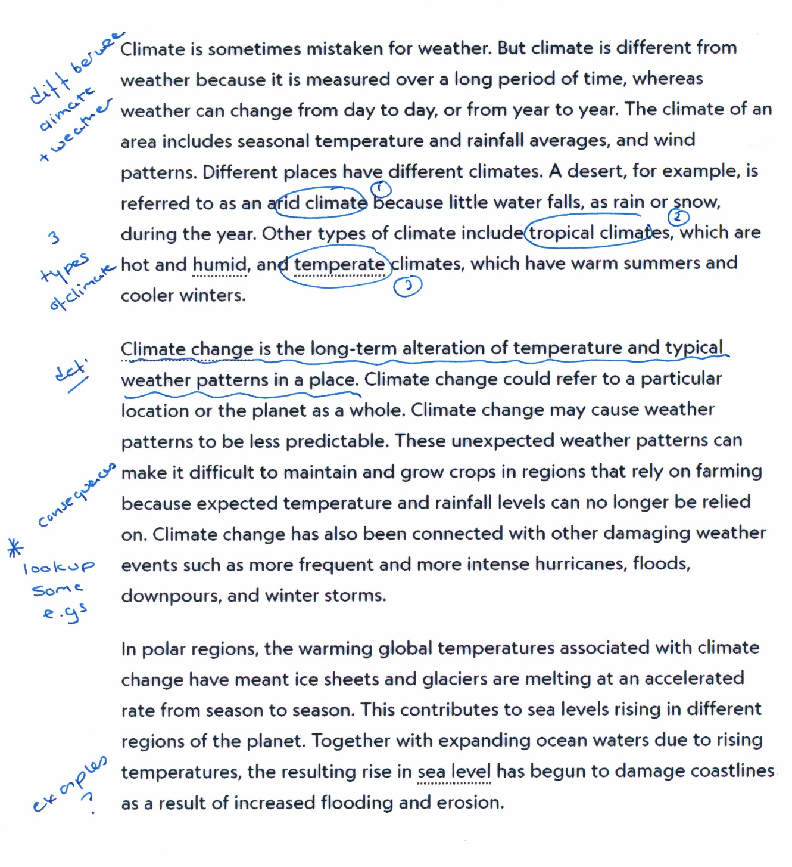

[Climate Change | National Geographic Society](https://www.nationalgeographic.org/encyclopedia/climate-change/)

**Mind-mapping**

Think carefully about mind-mapping. How useful is it?

****

It’s likely that you didn’t know anything about Tristan da Cuhna before you watched the video. How much can you remember now? There were 15 main points. How many can you remember?

|  |
| --- |
| **Information about Tristan da Cuhna** |
| 1. |
| 2. |
| 3. |
| 4. |
| 5. |
| 6. |
| 7. |
| 8. |
| 9. |
| 10. |
| 11. |
| 12. |
| 13. |
| 14. |
| 15. |

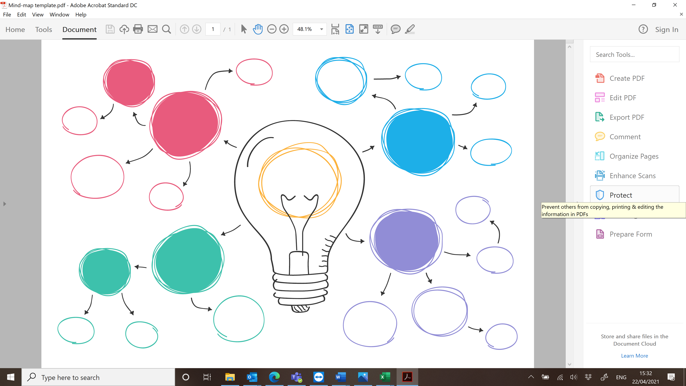

Mind-map template (you can download this from the website under ‘Reading Skills’)

****

Now think about topics that it would be useful for you to mind-map. List 5 in the box below.

|  |
| --- |
| **Topic to mind-map** |
| 1. |
| 2. |
| 3. |
| 4. |
| 5. |

You can access the mind-map template to print under the ‘Reading Skills’ section of the website

**Happy mind-mapping!**

****

**Condensing**

Remember the 80/20 rule. Here’s another text – this time it’s about why we laugh. It’s taken from: [The Science Of Laughter: Why Do We Laugh? » Science ABC](https://www.scienceabc.com/humans/science-laughter-reason-lol.html)

|  |
| --- |
| Laughter is essentially a person’s physiological reaction to hearing or seeing something humorous or funny.  So, what exactly is happening to our bodies when we laugh? As it turns out, the muscles of our entire face work in unison to bring about those joyous/crazy looks we have on our face when we laugh. In fact, laughter involves the **contraction of fifteen different facial muscles**. In addition, your breathing pattern changes, as your **epiglottis partially covers your larynx**, making you “gasp” for air. The most interesting physiological change that occurs are the “tears of joy” that we often experience after laughing hysterically. This is due to the **activation of the tear ducts**.  If we continue laughing hard for a long time, meaning that we continue gasping for air, **our face turns red** and our eyes begin to water due to a lack of oxygen intake (in extreme circumstances, we can even turn a hilarious shade of purple!)  If the question is taken in a more literal sense, then one would describe laughter as a repeating set of sounds, like “Ha ha” for example. This description isn’t far off from what’s actually happening. According to a study by laughter researcher Robert Provine, human laughter is basically a **repetition of short, vowel-like sounds** every 210 milliseconds. He says the laughter can come in different types, like “Ha-ha-ha” or “Ho-ho-ho”, but not a mixture of the two types.  To understand why we burst out laughing from time to time, let’s go back to our very beginnings. Think back to a time when fast food was literally an animal on four legs, running away from us, and we had to hunt it down to fill our bellies. At the same time, there were also animals running *towards us*, hunting *us* down to fill *their* bellies. At such times, our ancestors would’ve been under enormous amounts of stress while constantly trying to prolong and protect their lives. Therefore, it makes sense that when the danger finally passed, **early humans shared a laugh with one another as a sign of relief!** |

This text is 344 words. So, when you condense it, you should be able to get down to around 70 words. Try it now.

|  |
| --- |
| Start writing here |

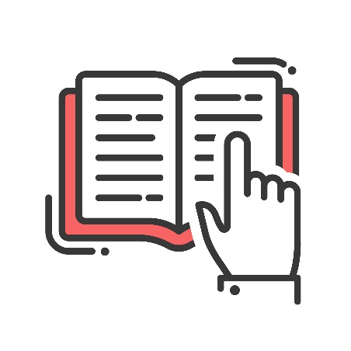

3

We hope you’ve enjoyed this reading module and that you have found the activities useful. Have a look at **Writing Skills** next.

