

Start My Journey

iCan Contribute helps by providing a way by which you can identify if you are a dreamer, a follower, a settler or an achiever. Each of these isn’t necessarily wrong but ask yourself if you are still being the dreamer in five years’ time…waiting for your Golden Ticket to happen and have missed creating and taking opportunities along the way, how would that make you feel?

By honestly assessing which of these you may be you can sharpen up your Golden Ticket and then begin to think about the key steps you want to take – your own personalised pathway to making your Golden Ticket real.

**Ships are safe in the harbour, but that’s not what ships are for.**

**Susan Jeffers**

**Activity: Plotting where you are now.**

To start your journey towards your Golden Ticket it is important to plot where you are now by honestly answering the following questions which will help you identify whether you are acting at this point as a follower, settler, dreamer or achiever.

**VISION**

**Score yourself out of 10 as to how clear, exciting and meaningful is your vision for the future.**

The following grid will help you score yourself in the area of vision:

1. Put a tick in ever box you agree with
2. Every Yes answer is worth 2 points, every to some extent is worth 1 point and ever no answer is worth 0 points. Add up your score at the bottom of the table

|  |  |  |  |  |
| --- | --- | --- | --- | --- |
| **Vision Questions** | **Yes** | | To some extent | No |
| Is my vision clear to me? |  | |  |  |
| Am I excited by my vision? |  | |  |  |
| Is my vision meaningful to me? |  | |  |  |
| Have I talked to others about my vision? |  | |  |  |
| Do I regularly think about my vision? |  | |  |  |
| Total Vision Score: | |  | | |

REALITY

**Score yourself out of 10 as to how proactive you have been in making your vision a reality.**

The following grid will help you score yourself in the area of Reality:

1. Put a tick in ever box you agree with
2. Every Yes answer is worth 2 points, every to some extent is worth 1 point and ever no answer is worth 0 points. Add up your score at the bottom of the table

|  |  |  |  |  |
| --- | --- | --- | --- | --- |
| **Reality Questions** | **Yes** | | To some extent | No |
| Do I feel like I am stretching my comfort zones? |  | |  |  |
| Am I doing new things? |  | |  |  |
| Am I grasping opportunities? |  | |  |  |
| Am I meeting new people? |  | |  |  |
| Am I pushing forward? |  | |  |  |
| Total Reality Score | |  | | |

Use your 2 total scores to plot yourself on the graph

We have indicated the category of each square on the graph.

For instance, if you score 4 for vision (the first table) and 6 for reality (the second table) you would look at the numbers along the bottom of the graph and stop at number 6. You would then move up the graph to number 4. The place where you find yourself is where you sit RIGHT NOW. In this instance, it would be Settler.

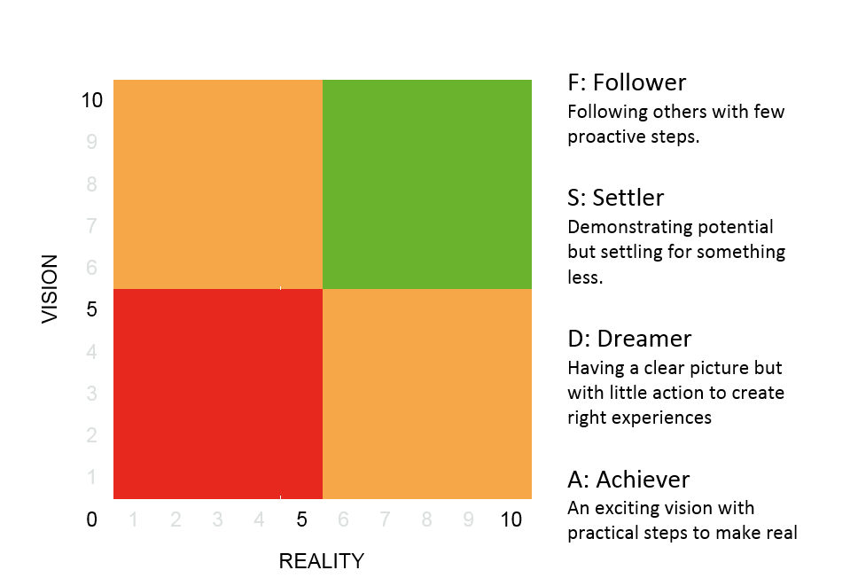

**Followers**

**Settlers**

**Achiever**

**Dreamer**



Having a clear, exciting and meaningful vision, and being proactive in making your vision a reality, you can change where you are on this graph. Only you can do this, but by putting into practice everything you have learnt so far are through completing the iCan process, you will be able to do so.

It is important to both raise your aspiration level and increase your realism. We have some top tips on what you might need to do in order to ensure you achieve this depending on where you currently sit within Followers, Settlers, a Dreamers and Achievers.

**Vision + Realism = Success**