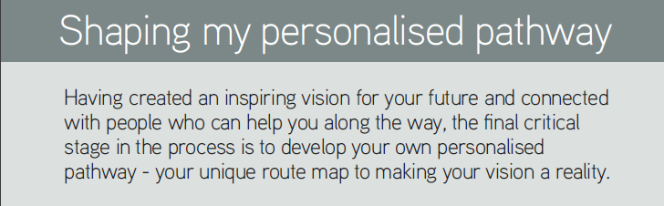
Shape My Pathway

WHERE DO I WANT TO BE?
Take a fresh look at your Golden Ticket and consider particular elements that really excite and inspire you. These may be about your ideal job, specific learning achievements or qualifications, fun experiences, positive people, or the difference you’ve made.

Focus on where you want to be, not where you were, or where you are.

Anonymous

ACTIVITY 1 – WHAT EXCITES AND INSPIRES YOU
Excite = to make somebody feel very pleased, interested or enthusiastic, especially about something that is going to happen.

Inspire = to give somebody the desire, confidence or enthusiasm to do something well

Now you have taken a fresh look at your Golden Ticket, choose one bit from each section; working, living, playing, giving, that really excites or inspires you.

The WORKING element of my Golden Ticket that really excites or inspires me is……
Click here to enter text.

This WORKING element of my Golden Ticket really excites or inspires me because………
Click here to enter text.

The LEARNING element of my Golden Ticket that really excites or inspires me is……
Click here to enter text.

This LEARNING element of my Golden Ticket really excites or inspires me because………
Click here to enter text.

The PLAYING element of my Golden Ticket that really excites or inspires me is……
Click here to enter text.

This PLAYING element of my Golden Ticket really excites or inspires me because………
Click here to enter text.

The GIVING element of my Golden Ticket that really excites or inspires me is……
Click here to enter text.

This GIVING element of my Golden Ticket really excites or inspires me because………
Click here to enter text.

ACTIVITY 2 – THE DREAM
Now imagine you’ve achieved all these things, and you’re living and breathing everything important to you in your Golden Ticket. You have reached your destination, the top right zone of the map. You have made your vision real.

What does this look like?
Click here to enter text.

How does it feel?
Click here to enter text.

What do you hear yourself and other people saying?
Click here to enter text.

