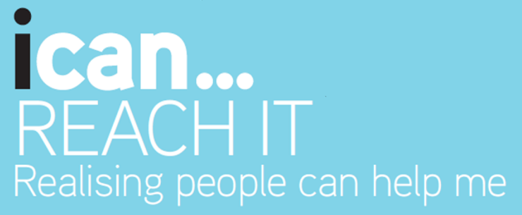

To realise your vision, overcome obstacles and make the most of opportunities you, may need to reach out for several helping hands along the way.

The first step in working out who can help you, is to spot who is there in the first place. As you go through your life you will meet all sorts of people from different aspects of your life e.g. working, learning, playing and giving, who can support you. Over the years as you experience more and more things, this group of people expands.

Your Playing network could be your friends and family

You will probably meet new people through your Learning at school, where you will meet other students, wider friends and teachers.

This then may go on to Giving where you are spending time volunteering or involved in community groups.

You then might go on to Working, meeting employers and colleagues.

“You can never cross the ocean until you have the courage to lose sight of the shore”
- Christopher Columbus

ACTIVITY 1 – MY SUPPPORT NETWORK

Now take a look at the table below of My Support Network and under each section make a note of all the people who could help you on your journey from each of the different categories. Remember this is not a numbers game with the winner being the person who has the most people listed. It is much more about the quality of relationships.

At this stage, leave the coloured columns empty.
Usually starting life within your family and then getting a few close friends who may share similar interests with you, this group of people could be categorised as your Playing network.

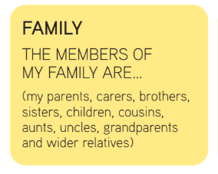 |  | 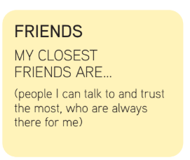

You will then probably begin to meet a new set of people through your Learning as you start school and go on to further education meeting other students, wider friends and teachers.

 |  | 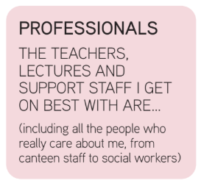 |  | 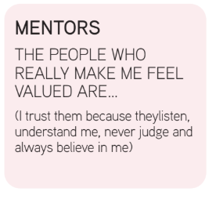

You may then go on to Working, meeting employers and work colleagues.

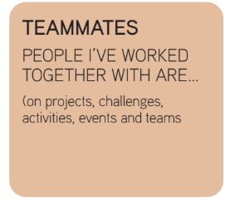 |  | 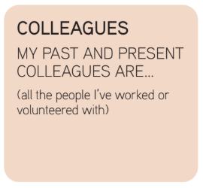

This may go on to Giving where you are spending time volunteering or involved in community groups

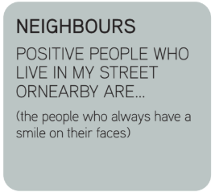 |  | 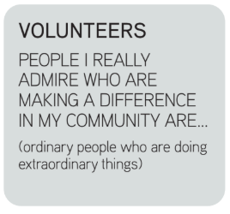 |  | 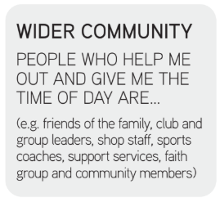

The people you have named in your Support Network will all offer different levels or ‘circles’ of support – core, supporters and wider community.

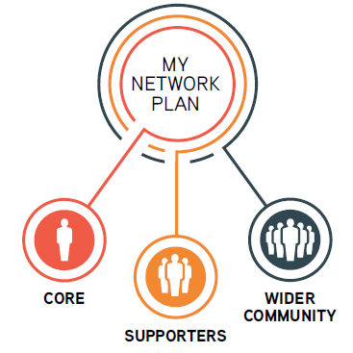

You have:

- Your Core network – those who are always there.

- Your Supporters – those who care about you but not in your core network.

- Your Wider Community – those who don’t know you quite as well.

Below are some activities that will help you to recognise who in your network fits in each group.

ACTIVITY 2 – CORE SUPPORT

The Core group consists of people who will be there for you all the time, no matter what, you only need to ask them. They may include parents, carers or particularly close friends who are always there to listen to you and will not judge. Again, there may not be a lot of people here. It is the quality of these relationships that matter not the number of them.

Put a number 1 in the coloured box next to the names of these people. These people make up your core group of support.

ACTIVITY 3 – SUPPORTER’S GROUP

Now think about your supporters. These build on those in your core group and are people who care about you and want to help but perhaps are not as freely accessible to you as your core group. It may include your wider group of friends, people you see in some of the clubs or groups you belong to.You may have wider family members, Uncles/Aunts or cousins or teachers, social workers, youth group leaders, employers etc.

In the coloured box at the side of these names put a number 2 as these people are in your supporter’s group.

ACTIVITY 4 – WIDER COMMUNITY

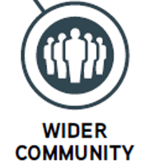
Finally, the remaining names on your list are the number 3’s and are part of your wider community. These may be people you know less well but who could also help you take those next few steps to making your vision a reality. They may be teachers in the school or college you attend but perhaps don’t teach you directly. They may be lecturers at the college you may want to go to or an employer who works in the field you would like to work in or who does the job you would like to do. They may be ex-students who have left your school or college or friends of friends; all these people may still be able to support you with what you want to do next.

In the coloured box at the side of the names left put a number 3 for your wider community.

All this network of people can provide help and support and you can keep growing it when you meet new people who may help you.

The benefit of a dynamic network of support is the quality of the relationships not the quantity. You may know some people who perhaps have a negative or unhealthy influence on you so you may not want them to be part of your network so leave them out, make sure they do not stop your achieving your vision.

