Discover
MoneyExplorer

WHO IS SUN?
Watch this short video to find out more about the Southern Universities Network.

Click the video above to play, or Click here to view in new browser.

HOW TO USE THIS WORKBOOK
- Save this Word Document to your own computer or device. It’s your workbook and no one else will have access to it.
- There will be videos throughout the workbook that introduce each topic, giving you important information or instructions that will help you complete each activity.
- As you work through the different activities, select your answers from the various drop-down menus or use the comment boxes to type your own.
- Work through the tasks at your own pace and remember to take regular breaks.
- When you have finished, we would appreciate it if you could complete a short survey to let us know how you found this workbook. Click on the link at the end to access the survey.
- You’ll also find information about how to enter our Prize Draw competition to win a £20 Amazon voucher at the end of the workbook.
INTRODUCTION TO MONEYEXPLORER
MoneyExplorer is a free online platform offering a wealth of impartial information about budgeting for Higher Education. It helps you to develop crucial money management skills, which are valuable for everyone but particularly relevant if you are considering university.
As you navigate the MoneyExplorer website you can earn online trophies relating to specific areas of budgeting such as; accommodation, food, work, and student finance. This develops your understanding of what you will need to budget for whilst in Higher Education, while highlighting the financial support available to you.
Watch this short video to find out more about this Discover MoneyExplorer Workbook
Click the video above to play, or Click here to view in new browser.

Now you have watched this video scroll down to the next page and have a go at the Student Finance activity.

WHAT IS STUDENT FINANCE?
Use the drop-down boxes to match the terms to their definition.
Choose an item. | Any money received, on a regular or casual basis, for work or through investments/ other sources.
Choose an item. | This is the amount of money lent to a UK student, by the government, to cover the cost of their tuition fees for a degree programme. No one has to pay the tuition fee upfront as everyone qualifies for one of these. You do not have to pay this loan back until after you graduate and are earning a certain amount.
Choose an item. | This is an amount of money, lent by the government, to pay for a UK student’s living costs whilst at university. This includes rent, food, bills, clothing etc.
Choose an item. | Part-time work means you will only work a few hours a week rather than 35 hours, which is classed as full-time work. People are considered to work part-time if they normally work fewer than 30 hours per week. Students typically work less than 16 hours per week.
Choose an item. | This is a grant or payment that is awarded to a student to help pay for their studies. They are often awarded because the student has excelled in a particular area or subject.
Choose an item. | A grant (which is an amount of money) given to someone to help them pay for the cost of university. Different universities have different ones of these available.

The PRIZE DRAW KEYWORD for this workbook is - *BUDGETING*
Remember this for when you enter our Prize Draw competition later.

SOURCES OF FINANCIAL SUPPORT
Choose which terms fit into each of the elements of financial support using the drop-down boxes.
ADDITIONAL INCOME
GOVERNMENT LOANS
POSSIBLE ADDITIONAL SUPPORT

STUDENT FINANCE
Choose an item. | Choose an item. | Choose an item.
Choose an item. | Choose an item. | Choose an item.

MONEY MINDMAP
Can you think of what a student might need to spend money on whilst at university?
Add text
Add text

Add text

Add text

Add text

Add text

Add text

USING THE MONEYEXPLORER WEBSITE
Click the video above to play, or Click here to view in new browser.

Now visit the MoneyExplorer website and start earning badges - https://uniexplorer.org/

Thank you
for completing THE ‘DISCOVER APPRENTICESHIPS workBOOK’ Created by SUN.
ANSWERS TO THE QUESTIONS & QUIZzES
BELOW YOU CAN FIND ALL THE Answers to the activities & QUIZZES in this workbook.
Once registered, make a note of your Unique Code below:
Click or tap here to enter text.
START EARNING TROPHIES
Use your budget book!
Remember to save!
Is your weekly spending more than your income?
What could you change?
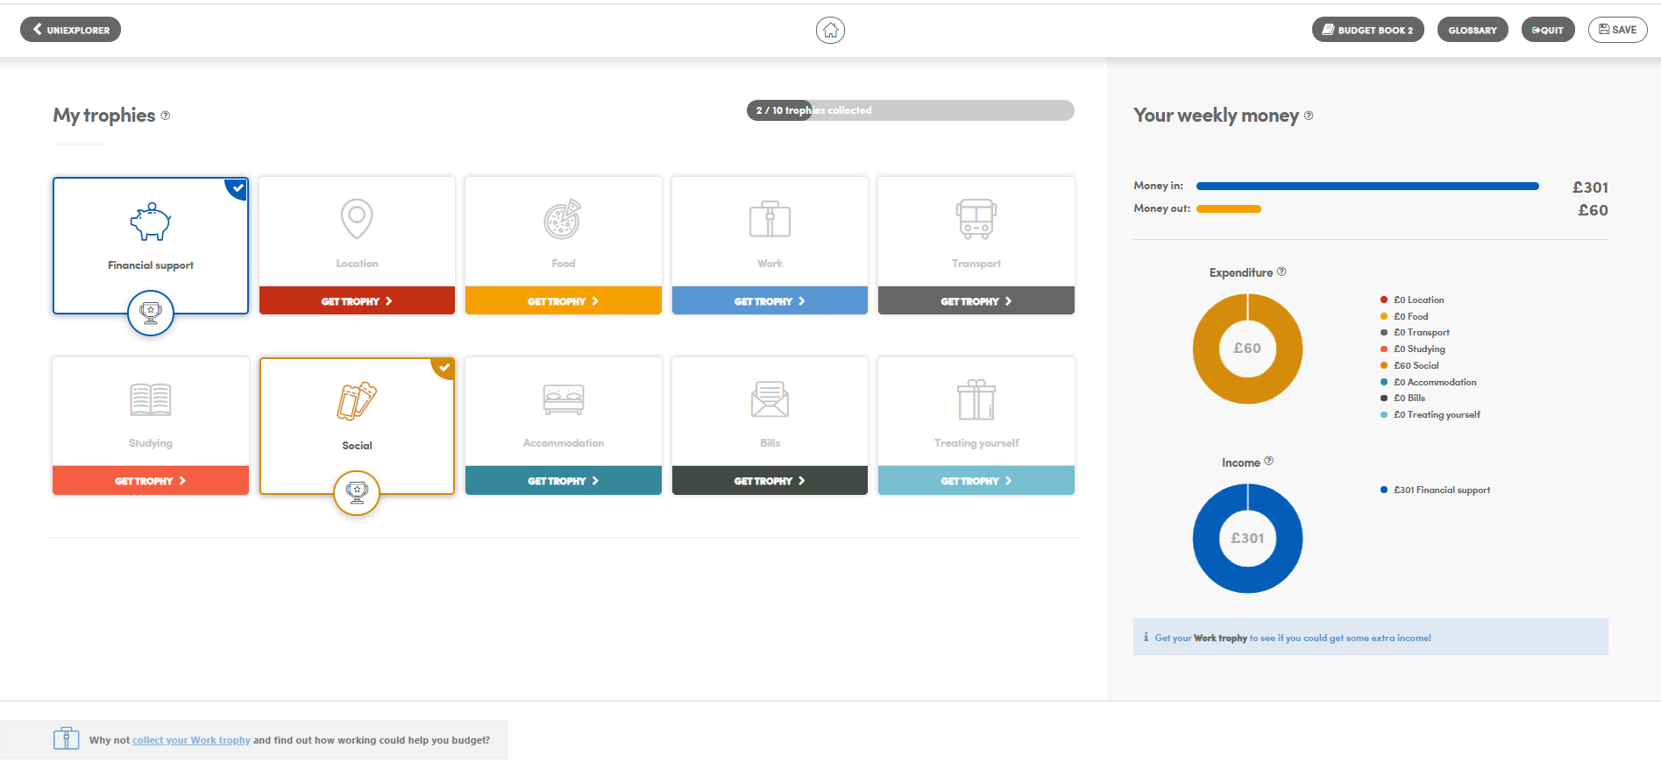

Work through the ‘Financial Support’ and ‘Social’ trophies and watch how your living costs and social arrangements affect your weekly budget.
EARNING EXTRA MONEY AS A STUDENT

Click the video above to play, or Click here to view in new browser.

PART TIME WORK QUIZ
Which of these points stated below were mentioned in the video?
Developing experience | ☐
It is best to work set hours rather than flexible shifts | ☐
University is all about the learning | ☐
Work around 25 hours a week | ☐
Making money | ☐
You could work as a Takeaway delivery driver | ☐
You could work as an NHS 111 call handler | ☐
Everybody has a job at university | ☐
Make sure you work before you finish your assignments | ☐
It is good to work as a Student Ambassador | ☐

NOW COMPLETE THE WORK QUIZ ON MONEYEXPLORER

NOW EARN EXTRA TROPHIES ON MONEYEXPLORER

WHAT NOW?
Click the video above to play, or Click here to view in new browser.

USEFUL LINKS
https://www.sunoutreach.org/resources/videos-university-costs/ - Our own website contains many pupil and parent guides, with links to workshops and events.
https://www.gov.uk/get-undergraduate-student-loan - Government website to calculate how much support you could get from tuition fee loan and maintenance loans.
https://university.which.co.uk/teachers/explain-finance-and-funding/the-complete-student-finance-guide - Which? University guide to student finance with free to download resources.
www.thecompleteuniversityguide.co.uk - Finance section containing guides to all areas of student finance and budgeting.
https://www.ucas.com/undergraduate/student-life/getting-student-support/undergraduate-student-finance-and-support - UCAS information page on all aspects of student finance including handy video guides.
-----------------------------------------------------------------------------------
Thank you
for completing THE DISCOVER MONEYEXPLORER workBOOK
Created by SUN.
ANSWERS TO THE QUESTIONS & QUIZzES
BELOW YOU CAN FIND ALL THE Answers to the activities & QUIZZES
in this workbook.
SHORT SURVEY
please ‘CLICK HERE’ TO complete our short survey and
give us your feedback.
PRIZE DRAW COMPETITION
£20 AMAZON VOUCHER
ONCE YOU HAVE COMPLETED THE INTERACTIVE WORKBOOK, ENTER OUR PRIZE DRAW. REMEMBER! YOU WILL NEED THE PRIZE DRAW *KEYWORD*
Please ‘CLICK HERE’ TO ENTER THE COMPETITION. GOOD LUCK!
Workbook Answers

STUDENT FINANCE ANSWERS
INCOME | Any money received, on a regular or casual basis, for work or through investments/ other sources.
TUITION LOAN | This is the amount of money lent to a UK student, by the government, to cover the cost of their tuition fees for a degree programme. No one has to pay the tuition fee upfront as everyone qualifies for one of these. You do not have to pay this loan back until after you graduate and are earning a certain amount.
MAINTENANCE LOAN | This is an amount of money, lent by the government, to pay for a UK student’s living costs whilst at university. This includes rent, food, bills, clothing etc.
PART TIME WORK | Part-time work means you will only work a few hours a week rather than 35 hours, which is classed as full-time work. People are considered to work part-time if they normally work fewer than 30 hours per week. Students typically work less than 16 hours per week.
SCHOLARSHIP | This is a grant or payment that is awarded to a student to help pay for their studies. They are often awarded because the student has excelled in a particular area or subject.
BURSARY | A grant (which is an amount of money) given to someone to help them pay for the cost of university. Different universities have different ones of these available.

MONEY MINDMAP ANSWERS
FOOD
STUDY COSTS

ACCOMODATION

SOCIALISING
BILLS

TREATING YOUSELF

TRAVEL

FINANCIAL SUPPORT ANSWERS
ADDITIONAL INCOME
GOVERNMENT LOANS
POSSIBLE ADDITIONAL SUPPORT

STUDENT FINANCE
MAINTENANCE LOAN | PART TIME WORK | BURSARY
TUITION LOAN | FAMILY SUPPORT | SCHOLARSHIP

click ON ANY OF THE LINKS below to try OUR
OTHER ONLINE WORKBOOKS:
DISCOVER APPRENTICESHIPS
DISCOVER CAMPUSEXPLORER
DISCOVER CAREERPILOT
DISCOVER YOUR OPTIONS

www.sunoutreach.org
Southern Universities Network
@SUN_Admin
southern_universities_network
🌐
Get Involved!
Click here to complete the Survey

