Discover
Careerpilot

WHO IS SUN?
Watch this short video to find out more about the Southern Universities Network.

Click the video above to play, or Click here to view in new browser.
HOW TO USE THIS WORKBOOK
- Save this Word Document to your own computer or device. It’s your workbook and no one else will have access to it.
- There will be videos throughout the workbook that introduce each topic, giving you important information or instructions that will help you complete each activity.
- As you work through the different activities, select your answers from the various drop-down menus or use the comment boxes to type your own.
- Work through the tasks at your own pace and remember to take regular breaks.
- When you have finished, we would appreciate it if you could complete a short survey to let us know how you found this workbook. Click on the link at the end to access the survey.
- You’ll also find information about how to enter our Prize Draw competition to win a £20 Amazon voucher at the end of the workbook.
WHAT WOULD YOU LIKE TO DO AFTER YEAR 11?
To get started, think of one thing you might like to do after Year 11. This could be a course, qualification, job or something else. Also, remember it’s ok to be unsure or not know.

Click or tap here to enter text.

CAREERPILOT – HOW TO CREATE YOUR OWN LOGIN
Watch the video below to see how to create a free account on Careerpilot.
Click the video above to play, or Click here to view in new browser.

Click here to get onto Careerpilot: https://www.careerpilot.org.uk/
Once registered, use the login reminder below:
Login Email:
Click or tap here to enter text.

Password Reminder:
Click or tap here to enter text.
SKILLS.
What do we mean by skills?
A skill is a talent or ability, which is developed through learning and/or experience.

Using the table below:
In the left-hand column, write down any skills you feel students may develop while at school.
In the right-hand column, tick any of the skills you feel you have already developed yourself.

Example: Presentation Skills
These are the skills you need to deliver effective and engaging presentations. These skills cover a variety of areas such as the structure of your presentation, the design of your slides, the tone of your voice and the body language you convey.

Skills | Do I feel I have this skill?
Click or tap here to enter text. | ☐
Click or tap here to enter text. | ☐
Click or tap here to enter text. | ☐
Click or tap here to enter text. | ☐
Click or tap here to enter text. | ☐

WHY ARE SKILLS IMPORTANT?
Skills are what make you employable and unique to a prospective employer.
Watch this video to find out more.
Click the video above to play, or Click here to view in new browser.

PRE-16 SKILLS MAP
Now let us have a look at your own skills.
The Pre 16 Skills Map will help you find out which skills you already have, and it is these skills that will be valued in future study and employment.
Watch the video below, and then head back over to Careerpilot to identify your skill set.
Click the video above to play, or Click here to view in new browser.

CELEBRITY SKILLS
In the table there are three celebrities, fill out their job sector using the drop-down options and type in their job role and any skills they need in order to do their job.
Celebrity | Job Sector & Job Title | Skills
Virgil Van Dijk | Job Sector:  Choose an item.  Job Title:  Click or tap here to enter text. | Skills:  Example: Team Work  Click or tap here to enter text.
Zendaya | Job Sector:  Choose an item.  Job Title:  Click or tap here to enter text. | Skills:  Example: Networking  Click or tap here to enter text.
Jamie Oliver | Job Sector:  Choose an item.  Job Title:  Click or tap here to enter text. | Skills:  Example: Management  Click or tap here to enter text.

Now have a go by inserting your own celebrities into the table. Find an image of your favourite celebrities and add them into the image box.
Celebrity | Job Sector &  Job Title | Skills
Click or tap here to enter text. | Job Sector:  Choose an item.  Job Title:  Click or tap here to enter text. | Skills:  Click or tap here to enter text.
Click or tap here to enter text. | Job Sector:  Choose an item.  Job Title:  Click or tap here to enter text. | Skills:  Click or tap here to enter text.
Click or tap here to enter text. | Job Sector:  Choose an item.  Job Title:  Click or tap here to enter text. | Skills:  Click or tap here to enter text.

QUALIFICATIONS
What is a qualification?
A qualification is what you receive once you have completed (subject) exams or courses and these qualify you to go onto particular courses/apprenticeships/jobs.

Qualifications Spotlight
Give the following qualifications a rating based on your understanding of each.
I have heard about this.
I have heard of this, but I’m not sure what it is.
I have not heard about this.

Qualification | Rating
A-Levels | Choose an item
BTEC | Choose an item
T-Level | Choose an item
Advanced Apprenticeship | Choose an item
HNC / HND | Choose an item
Degree | Choose an item
Higher / Degree Apprenticeship | Choose an item

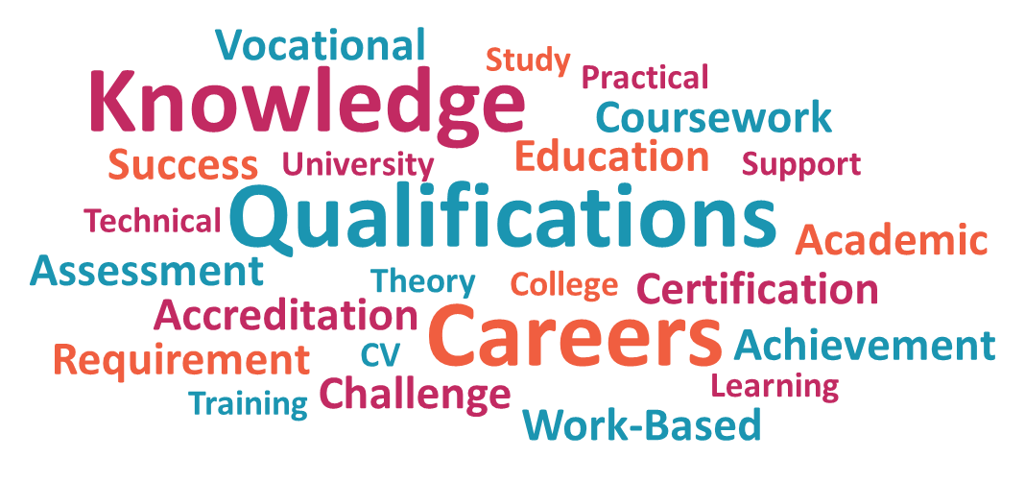

QUALIFICATIONS ON CAREERPILOT
To find out more about qualifications, watch our video and head back over to Careerpilot.
Click the video above to play, or Click here to view in new browser.

The PRIZE DRAW KEYWORD for this workbook is - *CAREERS*
Remember this for when you enter our Prize Draw competition later.
QUALIFICATION DEFINITIONS
Match the definition to the qualifications.
Definition | Qualification
This is a 2-year linear qualification, which has an academic focus. Typically, students take 3 options at level 3 in a range of subject areas. | Choose an item
This is a 2-year technical vocational qualification, which mixes classroom learning with practical work-based experience. This level 3 qualification is industry focused and includes a 45-day placement. | Choose an item
This is a type of level 2 and 3 vocational qualification, which is designed to help you learn in a practical way about a specific job area. | Choose an item
This is a work-based learning qualification, which requires students to have a real job with an employer, earning a wage, whilst gaining a level 3 qualification. | Choose an item
This level 6 qualification is gained by completing a 3 or 4-year course in a chosen subject area. The subject areas can range from academic to more practical workplace options. | Choose an item
These level 4 and 5 qualifications are designed to give you the skills and knowledge to perform in a particular job. These are highly valued by employer organisations due to their vocational focus. | Choose an item
This is a work-based learning qualification, which ranges from level 4-7. Students are able to work in a professional role, earning a wage, while working towards a higher or degree qualification. | Choose an item

JOB SECTORS.
What do we mean by a job sector?
An employment sector is a term which describes a group of jobs that fit together within an area of industry.

Introducing job sectors:
To start thinking about job sectors, look at the job roles below and add these to the correct section of the job sector table on the next page using the drop-down menus.

CIVIL ENGINEER
MASSAGE THERAPIST
EVENTS MANAGER

HAIRDRESSER
TOWN PLANNER
PRISON OFFICER

PARAMEDIC
ENTERTAINMENT AGENT

FITNESS INSTRUCTOR
ROYAL MARINES COMMANDO
VLOGGER
CRIMINOLOGIST
ARCHITECT
FASHION MODEL
INTERPRETER
ENVIRONMENTAL CONSULTANT
Job Sectors Table:

SPORT, LEISURE & TOURISM | SECURITY & EMERGENCY SERVICES
- Choose an item.  - Choose an item.  - Choose an item.  - Choose an item. | - Choose an item.  - Choose an item.  - Choose an item.  - Choose an item.
HAIR, BEAUTY & WELLBEING | CONSTRUCTION & THE BUILT ENVIRONMENT
- Choose an item.  - Choose an item.  - Choose an item.  - Choose an item. | - Choose an item.  - Choose an item.  - Choose an item.  - Choose an item.

JOB SECTORS ON CAREERPILOT
To find out more about job sectors, watch our video and head back over to Careerpilot.
Click the video above to play, or Click here to view in new browser.

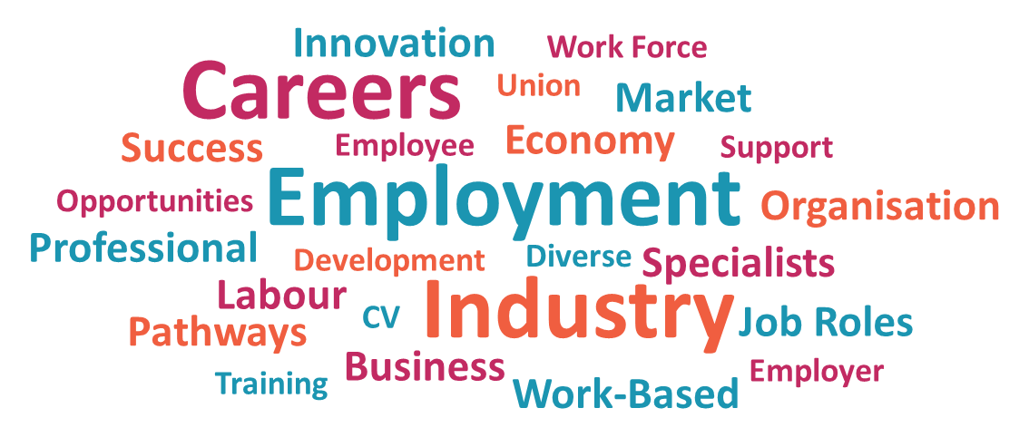

WHAT WOULD YOU LIKE TO DO AFTER YEAR 11?
Now you have explored Careerpilot, is there anything more you could add to your answer?
Do you have a clearer idea of the skills, qualifications, or course you need for your dream job?

Click or tap here to enter text.

CAREERPILOT FULL REPORT
How to download your full report on Careerpilot:
This short video shows you how you can find and download your full report.
Click the video above to play, or Click here to view in new browser.
-----------------------------------------------------------------------------------
Thank you
for completing THE DISCOVER CAREERPILOT workBOOK
Created by SUN.
ANSWERS TO THE QUESTIONS & QUIZzES
BELOW YOU CAN FIND ALL THE Answers to the activities & QUIZZES
in this workbook.
SHORT SURVEY
please ‘CLICK HERE’ TO complete our short survey and
give us your feedback.
PRIZE DRAW COMPETITION
£20 AMAZON VOUCHER
ONCE YOU HAVE COMPLETED THE INTERACTIVE WORKBOOK, ENTER OUR PRIZE DRAW. REMEMBER! YOU WILL NEED THE PRIZE DRAW *KEYWORD*
Please ‘CLICK HERE’ TO ENTER THE COMPETITION. GOOD LUCK!
Workbook Answers

SKILLS
Student Skills: can you name any student skills?
Here are just a few of the skills you may have come up with:
Communication | Being Punctual | Problem Solving
Thinking | Speaking | Creativity
Writing | Interpersonal Skills | Team Work
Listening | Commitment | Helping Others

Celebrity Skills: can you list their job role, job sector and skills?
These are just a few of the skills you may have come up with:
Celebrity | Job Sector | Job Role | Skills
Virgil Van Dijk | Sports & Leisure | Footballer | Focus  Determination  Resilience  Endurance  Communication
Zendaya | Media, Games & Performing Arts | Actress | Networking  Confidence  Performance Skills  Speaking  Communication  Resilience
Jamie Oliver | Hospitality & Catering | Celebrity Chef | Management Skills  Organisation  Entrepreneurial Skills  Global Awareness  Creativity  Communication

I hope that you also were able to think of some fantastic skills for your own favourite celebrities!

QUALIFICATIONS
Qualification Definitions: can you match the qualifications to their definitions?
Answer 1 | A-Level
Answer 2 | T-Level
Answer 3 | BTEC
Answer 4 | Advanced Apprenticeship
Answer 5 | Degree
Answer 6 | HNC / HND
Answer 7 | Higher / Degree Apprenticeship
JOB SECTORS
Job/Job sector match: can you match the job to the job sectors.
SPORT, LEISURE & TOURISM | SECURITY & EMERGENCY SERVICES
- Fitness Instructor  - Events Manager  - Entertainment Agent  - Interpreter | - Criminologist  - Prison Officer  - Royal Marines Commando  - Paramedic
HAIR, BEAUTY & WELLBEING | CONSTRUCTION & THE BUILT ENVIRONMENT
- Vlogger  - Fashion Model  - Hairdresser  - Massage Therapist | - Architect  - Civil Engineer  - Environmental Consultant  - Town Planner

click ON ANY OF THE LINKS below to try OUR
OTHER ONLINE WORKBOOKS:
DISCOVER APPRENTICESHIPS
DISCOVER CAMPUS EXPLORER
DISCOVER MONEY EXPLORER
DISCOVER YOUR OPTIONS
www.sunoutreach.org
Southern Universities Network
@SUN_Admin
southern_universities_network
🌐
Get Involved!
Click here to complete the Survey

