WELCOME TO iCan CREATE
HOW TO USE THIS WORKBOOK
- Save this Word Document to your own computer or device. It’s your workbook and no one else will have access to it.
- There is a video at the start of this workbook that introduces the topic, giving you important information or instructions that will help you complete each activity.
- As you work through the different activities, select your answers from the various drop-down menus or use the comment boxes to type your own.
- Work through the tasks at your own pace and remember to take regular breaks.
- When you have finished, save your work, take a break and when you are ready, move on to the next step on the Flying Start website.
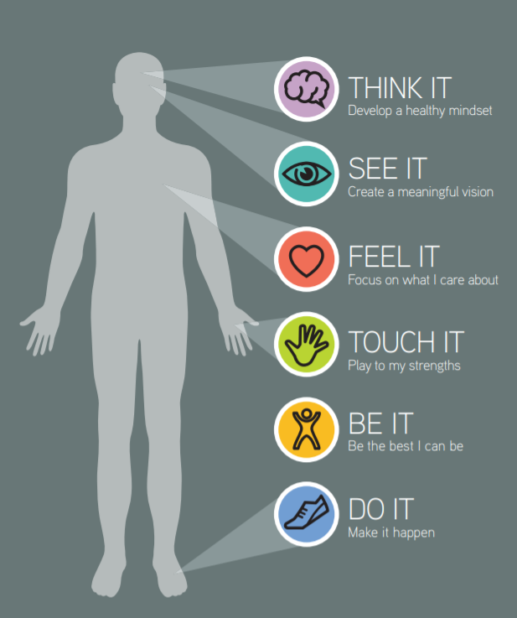

iCan will help you to create a vision for your future and take the first steps towards this.
BE THE BEST YOU CAN BE

Click the video above to play or Click here to view in new browser.

BE THE CHANGE THAT YOU WISH TO SEE IN THE WORLD
-Mahatma Gandhi

ACTIVITY 1: WORKING, LEARNING, PLAYING, GIVING (WLPG)
Have a look at the WLPG blends below. Can you match them with the descriptions?
WLPG blend | Use the drop-down menu to choose an answer
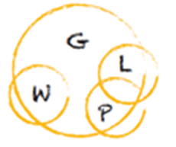 | Choose an item.
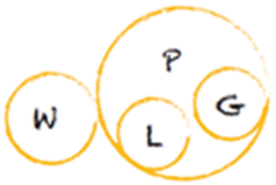 | Choose an item.
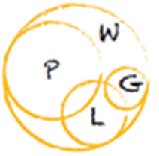 | Choose an item.
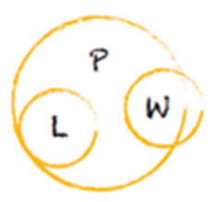 | Choose an item.
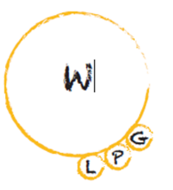 | Choose an item.
Burned out – unfulfilling work gobbles up life
Working to live – earning money to fuel a passion
Workaholic – passionate about work but no life outside
Generous – making a difference is more important
Self-centred – all about me, no giving to others
ACTIVITY 2: YOUR WLPG BLEND
Have a think about what your blend looks like today (‘on Tuesday’) and draw it on a spare piece of paper with your circles representing sizes in terms of time and energy and blend reflecting where the overlaps are. Once done, summarise this in the first box. Are you happy with how it looks? Is there anything you could do to improve it?

Now have a think about what you would like your blend to be for the rest of your life. Pick a date in the future and draw your ideal WLPG blend on your spare paper and summarise in the second box. Identify which of the four routes would be a good place to start using our top tips chart at the bottom of this page.

Don’t forget that everybody will have their unique route comprising a different combination and priority of Working, Learning, Playing and Giving. Be true to yourself when you are developing yours!
P
G
L
?
W

My WLPG blend today | My ideal WLPG blend in the future
Click or tap here to enter text. | Click or tap here to enter text.

Area of life | Things to consider
Working | - Seek out roles that interest you and maximise your strengths  - Find roles in organisations and sectors that appeal to you  - Get involved in projects, employer visits or information interviews  - Connect with people who work in areas that appeal to you
Learning | - Identify any further learning you may need to take to help you get closer to your goals  - Make sure that it links your aspirations with the needs of your target employers
Playing | - Create time and space to enjoy yourself  - Meet new people and develop your social circle – join a group who share a common interest, spend time with like-minded people  - Expose yourself to new possibilities, places and people
Giving | - Use volunteering as a stepping stone to gain new skills, contacts and experience  - Start by helping family and friends then look at opportunities to give back locally in your community  - Focus on purposes meaningful to you
Everybody will have their unique route comprising a different combination and priority of Working, Learning, Playing and Giving.
ACTIVITY 3: YOUR GOLDEN TICKET
Imagine yourself on the future date you picked in the previous activity and create your own Golden Ticket, a passport to the future you want, by completing the statements. Take some time to look back at your iCan poster so that your skills, passions and values are included in the Golden Ticket you create. Be big, bold, creative and imaginative with your responses.

GIVING: Tell us how you’re making a difference, what you’re giving your talents to and what greater impact you’re having:
LEARNING: Tell us about your qualifications and skills and how these make you more employable:
WORKING: Tell us about your ideal job, what you’ll do and what impact you’ll have:
Click or tap here to enter text.
Click or tap here to enter text.
PLAYING: Tell us about what you love doing, what you do for fun and the people you spend your time with:
Click or tap here to enter text.
Click or tap here to enter text.
OPTIONAL ACTIVITY: RECORD YOUR THOUGHTS (iCan Poster)
As you work your way through each section of iCan Create you will be prompted to use and record your thoughts as you go. Use the poster below to literally jot down any thoughts or ideas down, no matter how big or small.

Click or tap here to enter text.
Click or tap here to enter text.
Click or tap here to enter text.
Click or tap here to enter text.
Click or tap here to enter text.

