WELCOME TO iCan CREATE
HOW TO USE THIS WORKBOOK
- Save this Word Document to your own computer or device. It’s your workbook and no one else will have access to it.
- There is a video at the start of this workbook that introduces the topic, giving you important information or instructions that will help you complete each activity.
- As you work through the different activities, select your answers from the various drop-down menus or use the comment boxes to type your own.
- Work through the tasks at your own pace and remember to take regular breaks.
- When you have finished, save your work, take a break and when you are ready, move on to the next step on the Flying Start website.
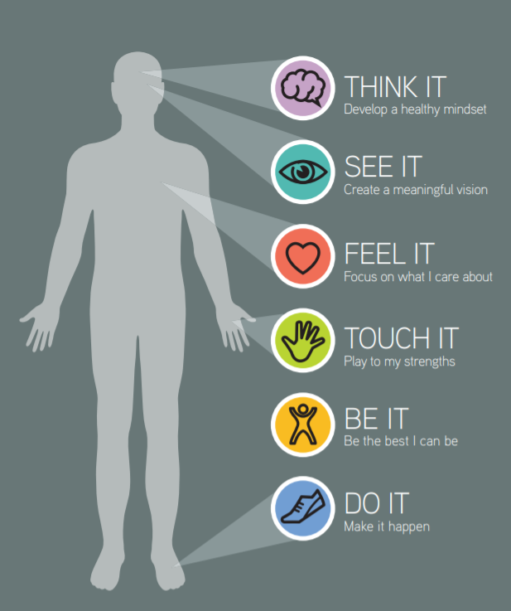

iCan will help you to create a vision for your future and take the first steps towards this.
PLAYING TO MY STRENGTHS

Click the video above to play, or Click here to view in new browser.

WE FIND OUR PURPOSE WHEN WE USE THE SKILLS WE LOVE, WHERE THE WORLD NEEDS THEM MOST.
- Richard N Bolles

ACTIVITY 1: ME & MY SKILLS
On the page below, you can see there are various groups of people who have differing interests and passions. Try to imagine you are at a party; there will be some groups you are more likely to talk and socialise with.
Take a couple of minutes to familiarise yourself with the 10 groups below and make a mental note of the ones you relate to most.
Once you have familiarised yourself with the groups, go through each groups and tick the skills you feel you have or are passionate about. Perhaps starts with your favourite groups.

The Musicians
People who like playing, composing or simply being around music
Performing | ☐
Collaborating | ☐
Practicing | ☐
Recording | ☐
Producing | ☐
Improvising | ☐
Orchestrating | ☐
Composing | ☐
Singing | ☐
Entertaining | ☐
The Actives
People who enjoy anything to do with Sport and Leisure
Exercising | ☐
Exploring | ☐
Well-being | ☐
Sporting | ☐
Adventuring | ☐
Playing | ☐
Dancing | ☐
Organising | ☐
Engaging | ☐
Travelling | ☐

The Handy-Andies
People who enjoy using their hands, making, preparing and fixing things.
Building | ☐
Preparing | ☐
Making | ☐
Crafting | ☐
Administrating | ☐
Cooking | ☐
Cleaning | ☐
Painting | ☐
Tending | ☐
Maintaining | ☐

The Creatives
People who love the arts, words, language, innovating, and using imagination.
Inventing | ☐
Creating | ☐
Imagining | ☐
Changing | ☐
Developing | ☐
Connecting | ☐
Drawing | ☐
Visioning | ☐
Writing | ☐
Designing | ☐

The Suits
People who love being in the world of commerce and business.
Selling | ☐
Persuading | ☐
Fundraising | ☐
Marketing | ☐
Enterprising | ☐
Leading | ☐
Initiating | ☐
Championing | ☐
Promoting | ☐
Risk-Taking | ☐
The Greenies
People who love nature, animals, the outdoors and/or care for the environment.
Protecting | ☐
Preserving | ☐
Salvaging | ☐
Planting | ☐
Conserving | ☐
Growing | ☐
Regenerating | ☐
Re-cycling | ☐
Tidying | ☐
Saving | ☐

The Communicators
People who love motivating, teaching, educating, selling, and negotiating.
Communication | ☐
Team Working | ☐
Teaching | ☐
Presenting | ☐
Listening | ☐
Motivating | ☐
Inspiring | ☐
Managing | ☐
Liaising | ☐
Educating | ☐
The Thinkers
People who like to reflect, think, philosophise, and make plans.
Reflecting | ☐
Thinking | ☐
Planning | ☐
Learning | ☐
Reviewing | ☐
Researching | ☐
Processing | ☐
Reading | ☐
Philosophising | ☐
Observing | ☐
The Mathematicians
People who love numbers, science, and logic.
Accounting | ☐
Evaluating | ☐
Solving | ☐
Analysing | ☐
Forecasting | ☐
Appraising | ☐
Budgeting | ☐
Financing | ☐
Computing | ☐
Systematising | ☐

Now in the table below select three groups which represent your skills and/or your personality.
This can be the ones you ticked the most skills for or just the ones you relate most to.
The Carers
People who like to help, cure or support others.
Helping | ☐
Caring | ☐
Sharing | ☐
Supporting | ☐
Understanding | ☐
Mentoring | ☐
Empowering | ☐
Befriending | ☐
Loving | ☐
Assisting | ☐

 | My Groups
1 | Choose an item.
2 | Choose an item.
3 | Choose an item.

ACTIVITY 2: SKILLS & EMPLOYMENT SECTORS
Firstly, when we talk about employment sectors, we mean areas of industry, which links several job roles together.
Use the diagram bellow to look through some of the employment sectors and think about the areas that interest you most.
Then, on the following page, use the sectors table to find more information and tick the sectors which you would like to pursue in the future.
If you can also think of some job roles for these sectors, perhaps roles that you would consider as a career later in life, add these into the fourth column of the table. Remember: Focus on the Job Sectors and Roles that most interest you.
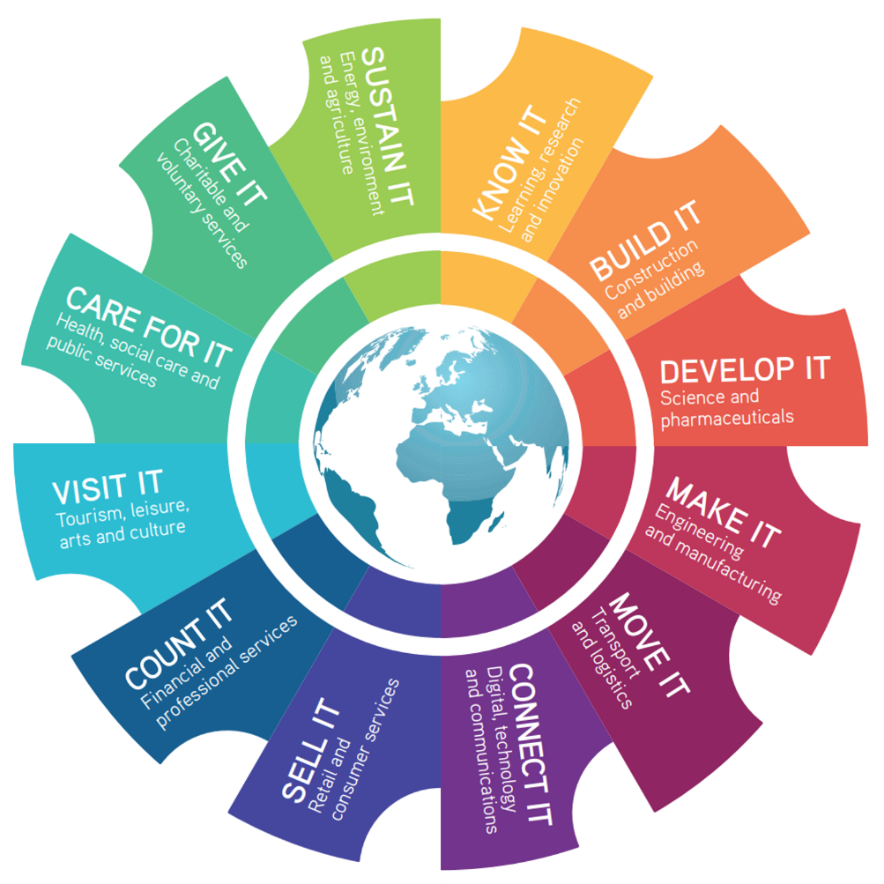

Sectors | Job Areas |  | Your Job Roles
 | Research, Education, Training, Market Research, & Innovation. | ☐ | Click or tap here to enter text.
 | Architecture, Construction, Maintenance, Civil & Structural Engineering. | ☐ | Click or tap here to enter text.
 | Pharmaceuticals, Robotics, Genetics, Product Development & Design. | ☐ | Click or tap here to enter text.
 | Engineering, Production, Textiles, Food & Drink. | ☐ | Click or tap here to enter text.
 | Distribution, Logistics, Supply Chain Management, & Transport. | ☐ | Click or tap here to enter text.
 | Web Design & Development, Software Development, Communications, & Media. | ☐ | Click or tap here to enter text.
 | Marketing, Advertising, Public Relations, Customer Services, & Fashion & Design. | ☐ | Click or tap here to enter text.
 | Accountancy, Finance, Management, Investment, Economy & Pensions. | ☐ | Click or tap here to enter text.
 | Arts, Tourism, Entertainment, Travel, Culture, Photography, Sport & Leisure. | ☐ | Click or tap here to enter text.
 | Medicine, Healthcare, Social Care, Social Work, Therapy, Fitness, & Public Services. | ☐ | Click or tap here to enter text.
 | Volunteering, Youth Work, Charities, Faith, Fundraising & Social Action. | ☐ | Click or tap here to enter text.
 | Farming, Energy, Utilities, Fishing, Animals, Ecology, & Conservation. | ☐ | Click or tap here to enter text.

Remember…
To be employed is to be at risk. To be employable is to be secure.
OPTIONAL ACTIVITY: RECORD YOUR THOUGHTS (iCan Poster)
As you work your way through each section of iCan Create you will be prompted to use and record your thoughts as you go. Use the poster below to literally jot down any thoughts or ideas down, no matter how big or small.

Click or tap here to enter text.
Click or tap here to enter text.
Click or tap here to enter text.
Click or tap here to enter text.
Click or tap here to enter text.

