WELCOME TO iCan CREATE
HOW TO USE THIS WORKBOOK
- Save this Word Document to your own computer or device. It’s your workbook and no one else will have access to it.
- There is a video at the start of this workbook that introduces the topic, giving you important information or instructions that will help you complete each activity.
- As you work through the different activities, select your answers from the various drop-down menus or use the comment boxes to type your own.
- Work through the tasks at your own pace and remember to take regular breaks.
- When you have finished, save your work, take a break and when you are ready, move on to the next step on the Flying Start website.
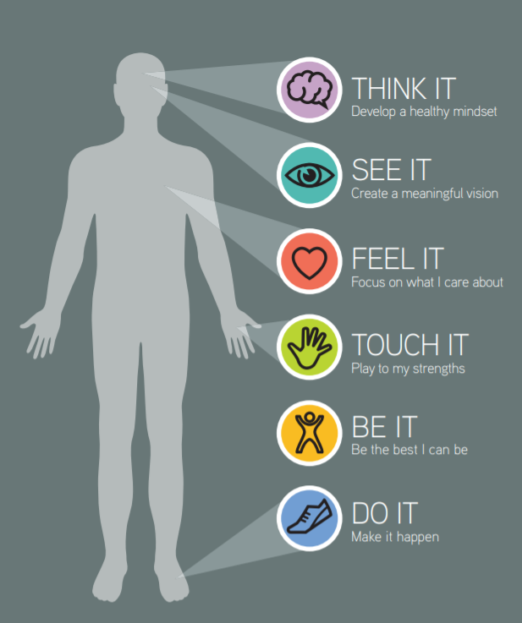

iCan will help you to create a vision for your future and take the first steps towards this.
You may have a positive mind-set and a clear vision to work towards, but unless this vision contains what you really care about, your heart won’t be in it.

Click the video above to play, or Click here to view in new browser.

IT’S NOT THE DAYS IN YOUR LIFE THAT COUNT IT’S THE LIFE IN YOUR DAYS.
- Demelza House Hospice

Be honest with yourself and think in your heart of hearts what do you care most about? What do you love doing? What do you believe in?

To help you answer, use the questions below to prompt some ideas, make a list of all the things you really care about. Make the list as big and creative as possible, looking at the whole of your life – your Working, Learning, Playing and Giving.

The heart of what matters | Think and Consider | Use the space below to type your response
Passions | What are you really passionate about? | Click or tap here to enter text.
Purpose | What purposes and causes would you like to give your time and talents to? | Click or tap here to enter text.
Excitement  and fun | What do you do with friends and/or at a weekend that gets you excited and helps you have fun? | Click or tap here to enter text.
Hobbies and interests | What hobbies or interests do you have, or would love to get involved in? | Click or tap here to enter text.
Fired up | What issues or topics get you most fired up? | Click or tap here to enter text.
Subjects | What are your favourite subjects? | Click or tap here to enter text.

ACTIVITY 1: THE DOORWAY TO YOUR PASSIONS
Now take a look at the images over the next four pages. Each of these is a potential “doorway” through which you may get opportunities to involve yourself with those things you care most about. Select all of the doorways that you feel passionate about.

CARE | 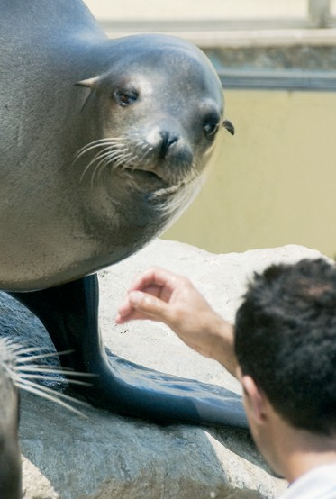  ANIMALS | ARTS
☐ | ☐ | ☐
BUSINESS | CHARITY | COMMUNICATIONS
☐ | ☐ | ☐
CONSTRUCTION | CREATIVITY | CULTURE
☐ | ☐ | ☐
REGIONS | RETAIL | TECHNOLOGY
☐ | ☐ | ☐
SPACE | SPORT | MYSTERY
☐ | ☐ | ☐
TRANSPORT | TRAVEL | WORLD AFFAIRS
☐ | ☐ | ☐
SCIENCE | FAITH | FASHION
☐ | ☐ | ☐
FINANCE | ENVIRONMENT | EQUALITY
☐ | ☐ | ☐
FAMILIES | ENGINEERING | ENTERTAINMENT
☐ | ☐ | ☐
EMPLOYMENT | VOLUNTEERING | YOUTH
☐ | ☐ | ☐
FOOD AND DRINK | HEALTH | HOMES
☐ | ☐ | ☐
JUSTICE | LEARNING | LANGUAGES
☐ | ☐ | ☐
MAKING | LIFESTYLE | MUSIC
☐ | ☐ | ☐
MEDIA | POLITICS | POVERTY
☐ | ☐ | ☐
PUBLIC SERVICE | OUTDOORS | PEOPLE
☐ | ☐ | ☐

ACTIVITY 2: IT’S MY LIFE AND I LOVE IT
There are lots of possibilities to bring the things you love to life. You can work with them, learn with them, play or give with them. Take a look at the list you have created and the doors you have ticked and choose a couple of items you enjoy the most for each of the working, learning, playing and giving circles below.

WORKING | I CAN WORK WITH… | Click or tap here to enter text.
LEARNING | I CAN LEARN MORE ABOUT… | Click or tap here to enter text.
PLAYING | I CAN PLAY AND HAVE FUN WITH… | Click or tap here to enter text.
GIVING | I CAN GIVE MY TIME/TALENTS TO… | Click or tap here to enter text.

Make a note of these in the ‘Feel It’ section of your iCan poster.
You may want to take this further by creatively combining some of your doors together. For example you may have chosen a sport door and an obvious way of getting involved with sport is by playing it. If, however, you combine sport with some of the other doors it can open up all kinds of other opportunities that will allow you to still get involved with sport but in a different way.

OPTIONAL ACTIVITY: RECORD YOUR THOUGHTS (iCan Poster)
As you work your way through each section of iCan Create you will be prompted to use and record your thoughts as you go. Use the poster below to literally jot down any thoughts or ideas down, no matter how big or small.

Click or tap here to enter text.
Click or tap here to enter text.
Click or tap here to enter text.
Click or tap here to enter text.
Click or tap here to enter text.

