WELCOME TO iCan CREATE
HOW TO USE THIS WORKBOOK
- Save this Word Document to your own computer or device. It’s your workbook and no one else will have access to it.
- There is a video at the start of this workbook that introduces the topic, giving you important information or instructions that will help you complete each activity.
- As you work through the different activities, select your answers from the various drop-down menus or use the comment boxes to type your own.
- Work through the tasks at your own pace and remember to take regular breaks.
- When you have finished, save your work, take a break and when you are ready, move on to the next step on the Flying Start website.
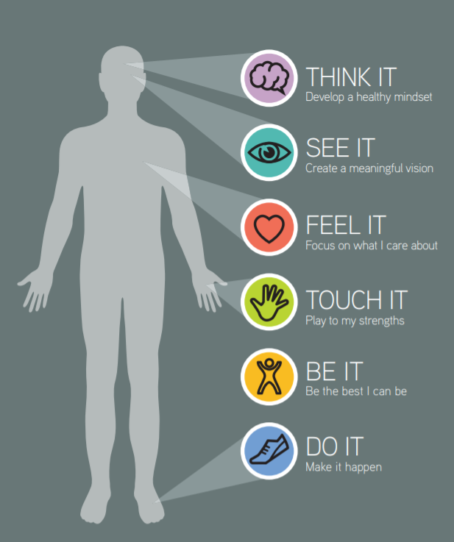

iCan will help you to create a vision for your future and take the first steps towards this.
Creating a clear vision for your life can help you shape a future for yourself rather than being influenced by other people.
Watch the video below and then work your way through this interactive worksheet.

Click the video above to play, or Click here to view in new browser.

Just for a bit of fun click on the ‘PLAY’ symbol below and have a go at our ‘Random Career Selector’:
What Career came up for you? | Click or tap here to enter text.
In developing an exciting and compelling vision, first be honest about what you truly value and see as important. Secondly, ensure your vision has realism, variety, detail and alternatives. Thirdly, keep re-evaluating your vision as it may evolve and change over time based on maturity and experiences. What you prioritise on the early days of the ‘week of your life’ may change by the weekend.

ACTIVITY 1: LOTTERY BALLS
Leaving things to chance can mean that you don’t fulfil your dreams in life, much like buying a ticket with the slimmest of chances of winning the lottery.

To avoid this happening consider choosing priorities for your life from the lottery balls shown below. There is even a bonus ball in there that can represent anything you want it to.

Tick the lottery balls below that mean the most to you and that you want to have in your life.

☐ | ☐ | ☐ | ☐
☐ | ☐ | ☐ | ☐

☐ | ☐ | ☐ | ☐
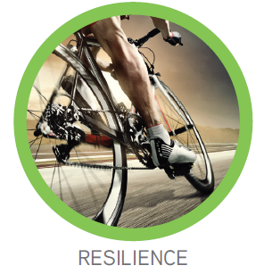 | 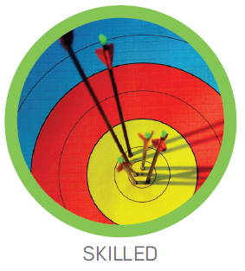
☐ | ☐ | ☐ | ☐
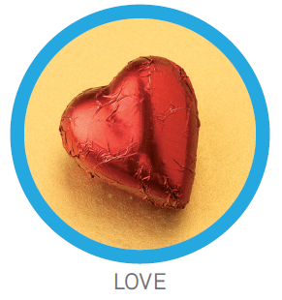
☐ | ☐ | ☐ | ☐
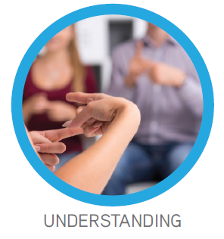
☐ | ☐ | ☐ | ☐
 | 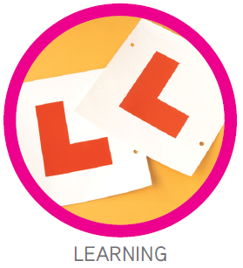
☐ | ☐ | ☐ | ☐
☐ | ☐ | ☐ | ☐
 | 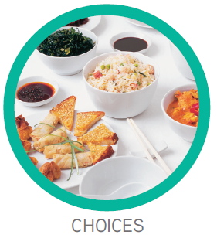
☐ | ☐ | ☐ | ☐
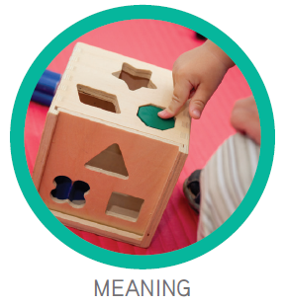
☐ | ☐ | ☐ | ☐
☐ | ☐ | ☐ | ☐
 |  |  | 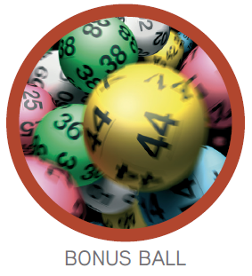
☐ | ☐ | ☐ | ☐

So by now you should have some lottery balls ticked that mean the most to you and that you want to have in your life. This can be as little or as many as you like.

Now think again about your future and out of those priorities you have already ticked you need to identify your top six lottery balls in the table on the next page (they can be from any section).

Pick the ones that you have either not got at all, or not got enough of now, that will play a big part in helping you to be happy, fulfilled and able to realise your true potential as you go through the week of your life.

Make a note of the six lottery balls you have chosen. You can also make a note of these in the ‘See It’ section of your iCan poster.

 | List your 6 lottery balls below | Why is this a priority for you? | What will this priority look like when you have it? | How can you make this priority happen?
1st | Click or tap here to enter text. | Click or tap here to enter text. | Click or tap here to enter text. | Click or tap here to enter text.
2nd | Click or tap here to enter text. | Click or tap here to enter text. | Click or tap here to enter text. | Click or tap here to enter text.
3rd | Click or tap here to enter text. | Click or tap here to enter text. | Click or tap here to enter text. | Click or tap here to enter text.
4th | Click or tap here to enter text. | Click or tap here to enter text. | Click or tap here to enter text. | Click or tap here to enter text.
5th | Click or tap here to enter text. | Click or tap here to enter text. | Click or tap here to enter text. | Click or tap here to enter text.
6th | Click or tap here to enter text. | Click or tap here to enter text. | Click or tap here to enter text. | Click or tap here to enter text.

YOUR NEXT CHAPTER
As you begin to consider the rest of the week of your life you are about to start a new chapter, so what do you want the ‘SCRIPT’ of your next chapter to be? (Survival, Confidence, Relationships, Improvement, Purpose, Time).

Realising our full potential relies on us first having the basic foundations of life to survive, we can then begin to grow in confidence and develop our relationships. Continuing to improve can lead to a greater sense of purpose and the opportunity to create time to make a difference using our unique combination of skills and talents.
ACTIVITY 2: YOUR PRIORITIES
Using the colour coding below can help you to identify where your priorities lie in your future script. | How many lottery balls did you select in each section
 | Choose an item.
 | Choose an item.
 | Choose an item.
 | Choose an item.
 | Choose an item.
 | Choose an item.

So using the colour-coding SCRIPT chart above, what aspect did you score the highest amount of lottery balls in?
Record your answer here: | Click or tap here to enter text.
Identifying where your priorities lie in your future ‘SCRIPT’ is great, as it plays a huge part in you ‘SEEING’ what is important to you, for your life journey.
However, remember things can change and so can your priorities in life, so what is important to you right now may not be in a year or two’s time. Use this ‘SEE IT’ section from time to time to re-evaluate your priorities.
We hope you have enjoyed the ‘SEE IT’ section and before you move on to the ‘FEEL IT’ section remember to record any thoughts in the iCan Poster on the next page.

OPTIONAL ACTIVITY: RECORD YOUR THOUGHTS (iCan Poster)
As you work your way through each section of iCan Create you will be prompted to use and record your thoughts as you go. Use the poster below to literally jot down any thoughts or ideas down, no matter how big or small.

Click or tap here to enter text.
Click or tap here to enter text.
Click or tap here to enter text.
Click or tap here to enter text.
Click or tap here to enter text.

