

WELCOME TO i**Can** CREATE

**HOW TO USE THIS WORKBOOK**

* Save this Word Document to your own computer or device. It’s your workbook and no one else will have access to it.
* There is a video at the start of this workbook that introduces the topic, giving you important information or instructions that will help you complete each activity.
* As you work through the different activities, select your answers from the various drop-down menus or use the comment boxes to type your own.
* Work through the tasks at your own pace and remember to take regular breaks.
* When you have finished, save your work, take a break and when you are ready, move on to the next step on the Flying Start website.

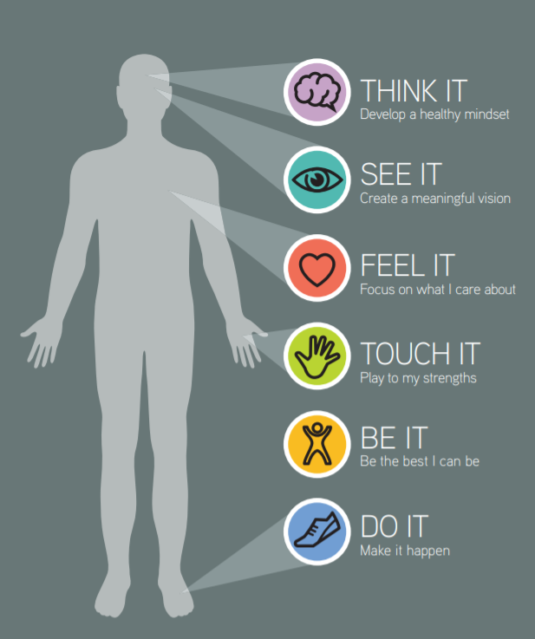

iCan will help you to create a vision for your future and take the first steps towards this.

Changing the way you think – your mindset, can change your life. And the exciting thing is you have the choice to do this.

Watch the introductory video below and then work your way through this interactive worksheet.



Click the video above to play or [Click here](https://youtu.be/kuayu6bRxwE) to view in new browser.

**IF YOU THINK YOU CAN OR YOU THINK YOU CAN’T YOU ARE RIGHT.**

* **Henry Ford**

**ACTIVITY 1: WHAT’S ON YOUR PLATE?**

The plate images below represent the different things you could have on your plate at different times of your life. Take a look at the plate images below that might represent aspects of your life. Tick the 3 plates that have played a significant part in your life.

|  |  |  |  |  |  |  |  |
| --- | --- | --- | --- | --- | --- | --- | --- |
|  | |  | |  | |  | |
| EMOTIONAL WELLBEING | | PASSIONS | | FRIENDS | | MONEY | |
|  | |  | |  | |  | |
|  | |  | |  | |  | |
| SECURITY | | DIFFERENCE | | HEALTH | | SADNESS | |
|  | |  | |  | |  | |
|  | |  | |  | |  | |
| FAMILY | | DEATH | | OPPORTUNITY | | FOCUS | |
|  | |  | |  | |  | |
|  | |  | |  | |  |
| SURPRISES | | WORK | | LEARNING | | CHALLENGES |
|  | |  | |  | |  |
|  | |  | |  | |  |
| DISASTERS | | ROLES | | CHANGE | | MESS |
|  | |  | |  | |  |
|  | |  | |  | |  |
| HAPPINESS | | SUCCESS | | CELEBRATION | | VALUES |
|  | |  | |  | |  |

Using the table below insert the plates you chose and explain why this has been significant.

|  |  |
| --- | --- |
| **Plate** | **Why?** |
| Choose an item. | Click or tap here to enter text. |
| Choose an item. | Click or tap here to enter text. |
| Choose an item. | Click or tap here to enter text. |

**ACTIVITY 2: DEVELOP A HABIT**

What would you like to have on your plate at 30, what positive thinking habits do you need to develop to make these a reality? In the table below, choose a plate and explain what positive thinking habits you will need in order to make this real.

What can you do to think and act positively to deal with these just now?

Type your answer below.

|  |
| --- |
| Click or tap here to enter text. |

**ACTIVITY 3: LEARN FROM ROLE MODELS**

Think about a role model in your life – people who are important to you, have made a difference, people you believe in and people you really inspire to be more like – this doesn’t need to be a celebrity, this could be members of your family, friends or community who inspire you.

Complete the table below with this in time.

|  |  |
| --- | --- |
| **Your Role Model** | **What has shaped them to be who they are?** |
| Question Mark Person Icon, HD Png Download , Transparent Png Image ... | Click or tap here to enter text. |
| **What positive thoughts do they use to overcome challenging events?** |
| Click or tap here to enter text. |
| **What words of advice would they give you?** |
| Click here to enter name | Click or tap here to enter text. |

|  |  |
| --- | --- |
| **Plate** | **Positive thinking habits** |
| Choose an item. | Click or tap here to enter text. |
| Choose an item. | Click or tap here to enter text. |
| Choose an item. | Click or tap here to enter text. |

**OPTIONAL ACTIVITY: RECORD YOUR THOUGHTS (iCan Poster)**

As you work your way through each section of iCan Create you will be prompted to use and record your thoughts as you go. Use the poster below to literally jot down any thoughts or ideas down, no matter how big or small.

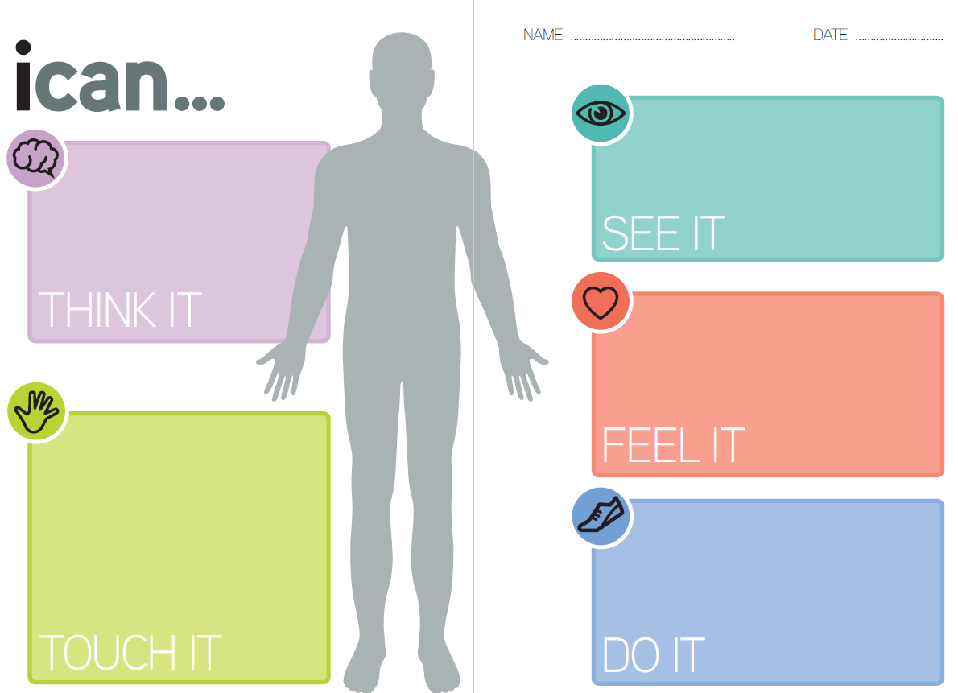

Click or tap here to enter text.

Click or tap here to enter text.

Click or tap here to enter text.

Click or tap here to enter text.

Click or tap here to enter text.