WELCOME TO iCan CREATE
HOW TO USE THIS WORKBOOK
- Save this Word Document to your own computer or device. It’s your workbook and no one else will have access to it.
- There is a video at the start of this workbook that introduces the topic, giving you important information or instructions that will help you complete each activity.
- As you work through the different activities, select your answers from the various drop-down menus or use the comment boxes to type your own.
- Work through the tasks at your own pace and remember to take regular breaks.
- When you have finished, save your work, take a break and when you are ready, move on to the next step on the Flying Start website.
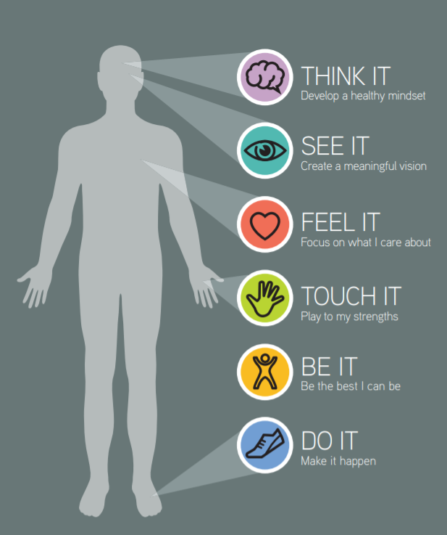

iCan will help you to create a vision for your future and take the first steps towards this.
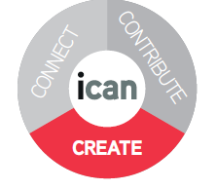
MAKE EVERY DAY COUNT
Watch the introductory video below and then work your way through this interactive worksheet.
Click the video above to play, or Click here to view in new browser.

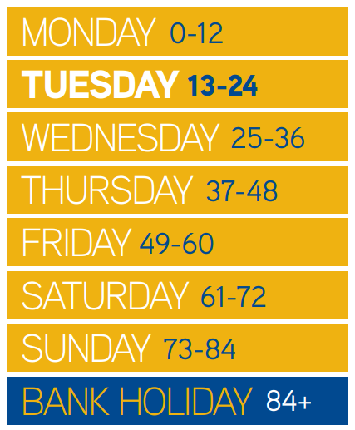

There are seven billion people on this planet with only two things in common. We are all born and we all die. The bit in between is that thing called – our life.
Imagine your life as a week with each day representing 12 years. You are born on Monday morning and 12 by Monday night, 36 on Wednesday, 60 by Friday evening, 84 by Sunday and if you are lucky, you may get a bank holiday Monday too.
ACTIVITY 1: DAYS OF THE WEEK
For a moment just consider your journey so far from 0-12 years old. What has it been like for you? Use the table below to answer how life has been on Monday.
Day of the week | Think and Consider | Use the space below to type your response
Monday 0-12 | What have you learnt or celebrated? | Click or tap here to enter text.

So now repeat the task above, but move on to Tuesday (the day of the week you are actually now on) consider the kind of decisions you may make in your life on this particular day. Think about what have you learned? What have you celebrated in this time? A lot can happen between 13 and 24 and much of the following week can be shaped by what you decide on Tuesday.
Day of the week | Think and Consider | Use the space below to type your response
Tuesday 13-24 | What have you learnt or celebrated? | Click or tap here to enter text.

Now imagine you’re on Sunday evening (84 years old) and moving into the Bank Holiday (85+). Looking back over the week of your life. It has been amazing, you’ve had a great time – what kind of things do you think you would be celebrating and be thankful for?
Day of the week | Think and Consider | Use the space below to type your response
Bank Holiday 85+ | What have you learnt or celebrated? | Click or tap here to enter text.

ACTIVITY 2: LIFE DECISIONS
Matching task: Match the life decisions and celebrations to the day of the week.
Decisions & Celebrations | Choose the ‘day of the week’ you think these are most likely to occur.
Gained lifelong friends | Choose an item.
Decided to go to University | Choose an item.
Decided to run my own business | Choose an item.
Won a competition with a team | Choose an item.
Passed my driving test | Choose an item.
Achieved certificates / qualifications | Choose an item.
Decided to live / work / or study abroad | Choose an item.
Graduated and got a Degree | Choose an item.
Decided to have a family | Choose an item.
Decided I wanted to change career | Choose an item.
Got married | Choose an item.
Completed an Apprenticeship | Choose an item.
Purchased my first house | Choose an item.
Went on my first holiday with friends | Choose an item.
Decided to learn something new and take up a new hobby (e.g. musical instrument, cooking etc.) | Choose an item.
Landed my dream job | Choose an item.
Decided to give something back and volunteer | Choose an item.

The moral of this activity is that you can make decisions and celebrate lots during the course of your life, and life is what you make it.
Also, remember there is no written rule as to what age or time in your life you can achieve and celebrate things.
MAKING A START
Watch the video below as it introduces you to the third activity. This activity will help you to develop a healthy mindset and a meaningful vision. By learning more about yourself and what you want for the future, the easier it will be to develop a set of actions, which will enable you to move closer towards your future vision.
Click the video above to play, or Click here to view in new browser.

To grow yourself, you must know yourself.
- John C. Maxwell
ACTIVITY 3: PLOT YOUR RESULTS
It doesn’t matter what day of the week you are on, however challenging yesterday has been, it’s up to you to make the most of the rest of your week. iCan is about helping you to take control and realise your potential by developing a healthy mind-set, creating a meaningful vision, focusing on what you care about, playing to your strengths and making things happen. So how are you scoring on these elements at the moment? Score your responses below.

iCan Elements |  | Question for you? | As honestly, as you can select your score in the table below  (0 = very poor, 10 = highly effective)
 | THINK IT  Develop a healthy mind-set | How positive, resilient and hopeful do you think you are? | Choose an item.
 | SEE IT  Create a meaningful vision | How clear and meaningful is your vision for the future? | Choose an item.
 | FEEL IT  Focus on what I care about | How involved are you in the things you care about? | Choose an item.
 | TOUCH IT  Play to my strengths | How well are you playing to your strengths? | Choose an item.
 | SEE IT  Make it happen | How proactive are you in making things happen? | Choose an item.

OPTIONAL ACTIVITY: RECORD YOUR THOUGHTS (iCan Poster)
As you work your way through each section of iCan Create you will be prompted to use and record your thoughts as you go. Use the poster below to literally jot down any thoughts or ideas down, no matter how big or small.

Click or tap here to enter text.
Click or tap here to enter text.
Click or tap here to enter text.
Click or tap here to enter text.
Click or tap here to enter text.

